Monday 4th, May

A life without gadgets.

1. Read the text. *(You can use the dictionary* <https://www.wordreference.com/es/> )

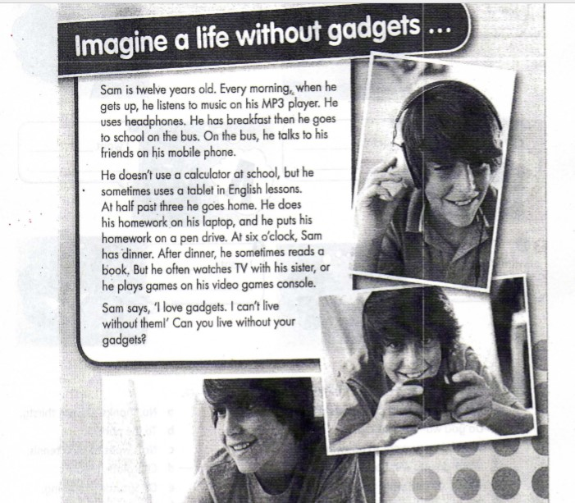

1. Write the 7 gadgets Sam uses.

*Sam uses:*

* *An MP3*
* *Headphones*

1. Read and match (Escribiendo la letra al lado del número como el ejemplo)
2. *Sam talks to his Friends a. on a pen drive*
3. *He listens to music b. after dinner*
4. *He sometimes uses a tablet c. on his mobile phone*
5. *He does his homework ~~d. on his laptop~~*
6. *He puts his homework e. when he gets up*
7. *He often watches TV f. at school*
8. *D*