Thursday, 4th June

**Booklet (page 67)**

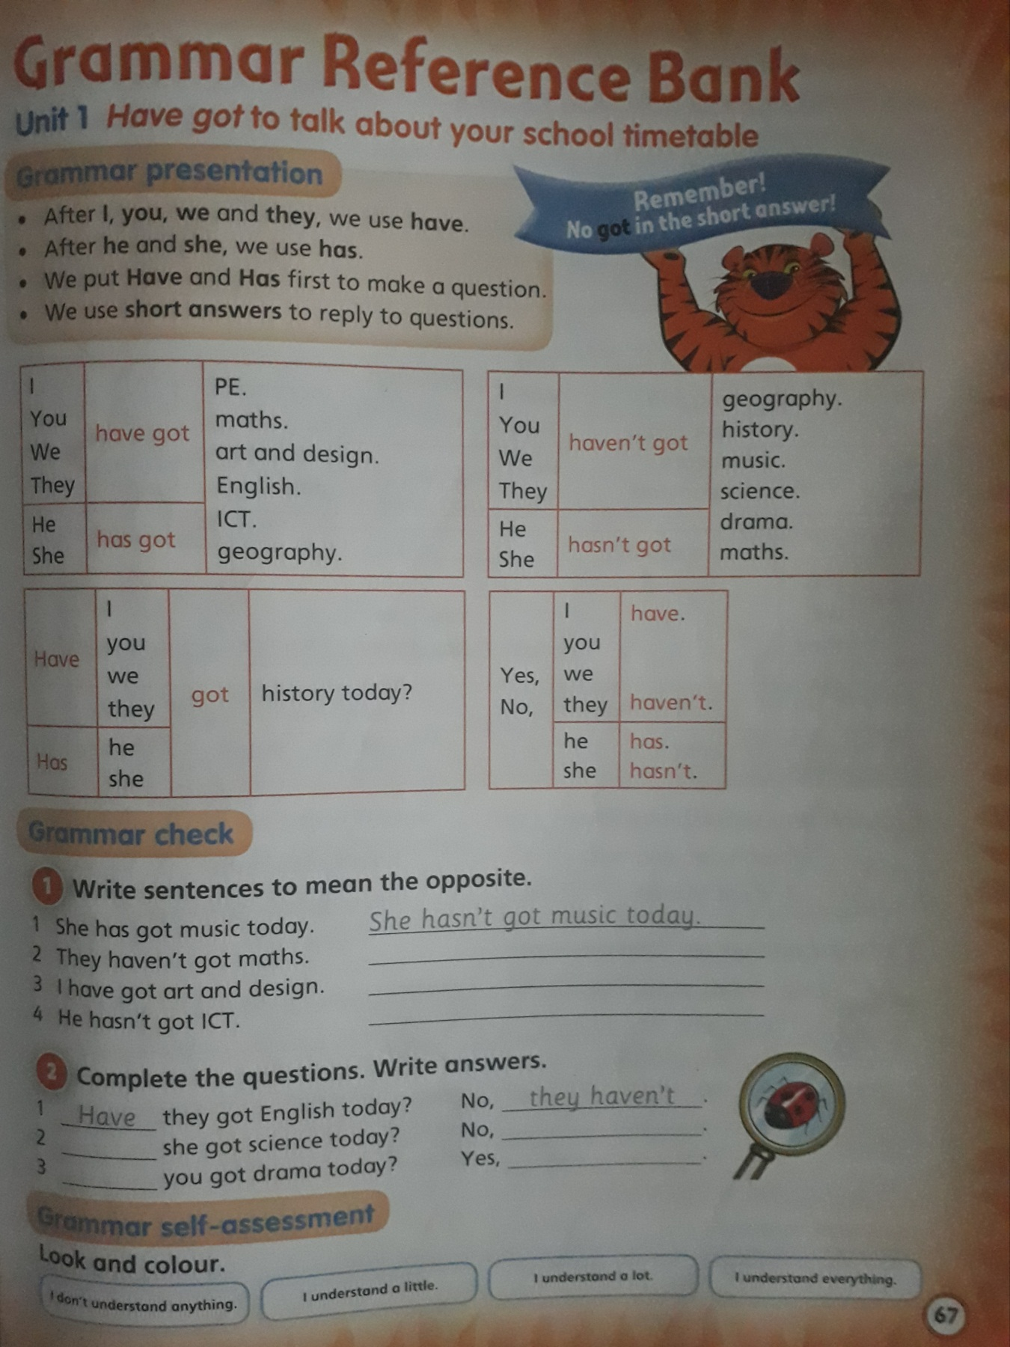

**Activity 1:**

1. **She hasn’t got music today.**

**2-**

**3-**

**4-**

**Activity 2:**

1. **Have they got English today?**

**No, they haven’t.**

1. **…….. she got science today?**

**No,……………………**

1. **………… you got drama today?**

**Yes, ………………………**

**Booklet (page 74)**

Vocabulary and grammar reinforcement: complete the activities on page 74 in your booklet in order to revise what you´ve learnt during this unit.

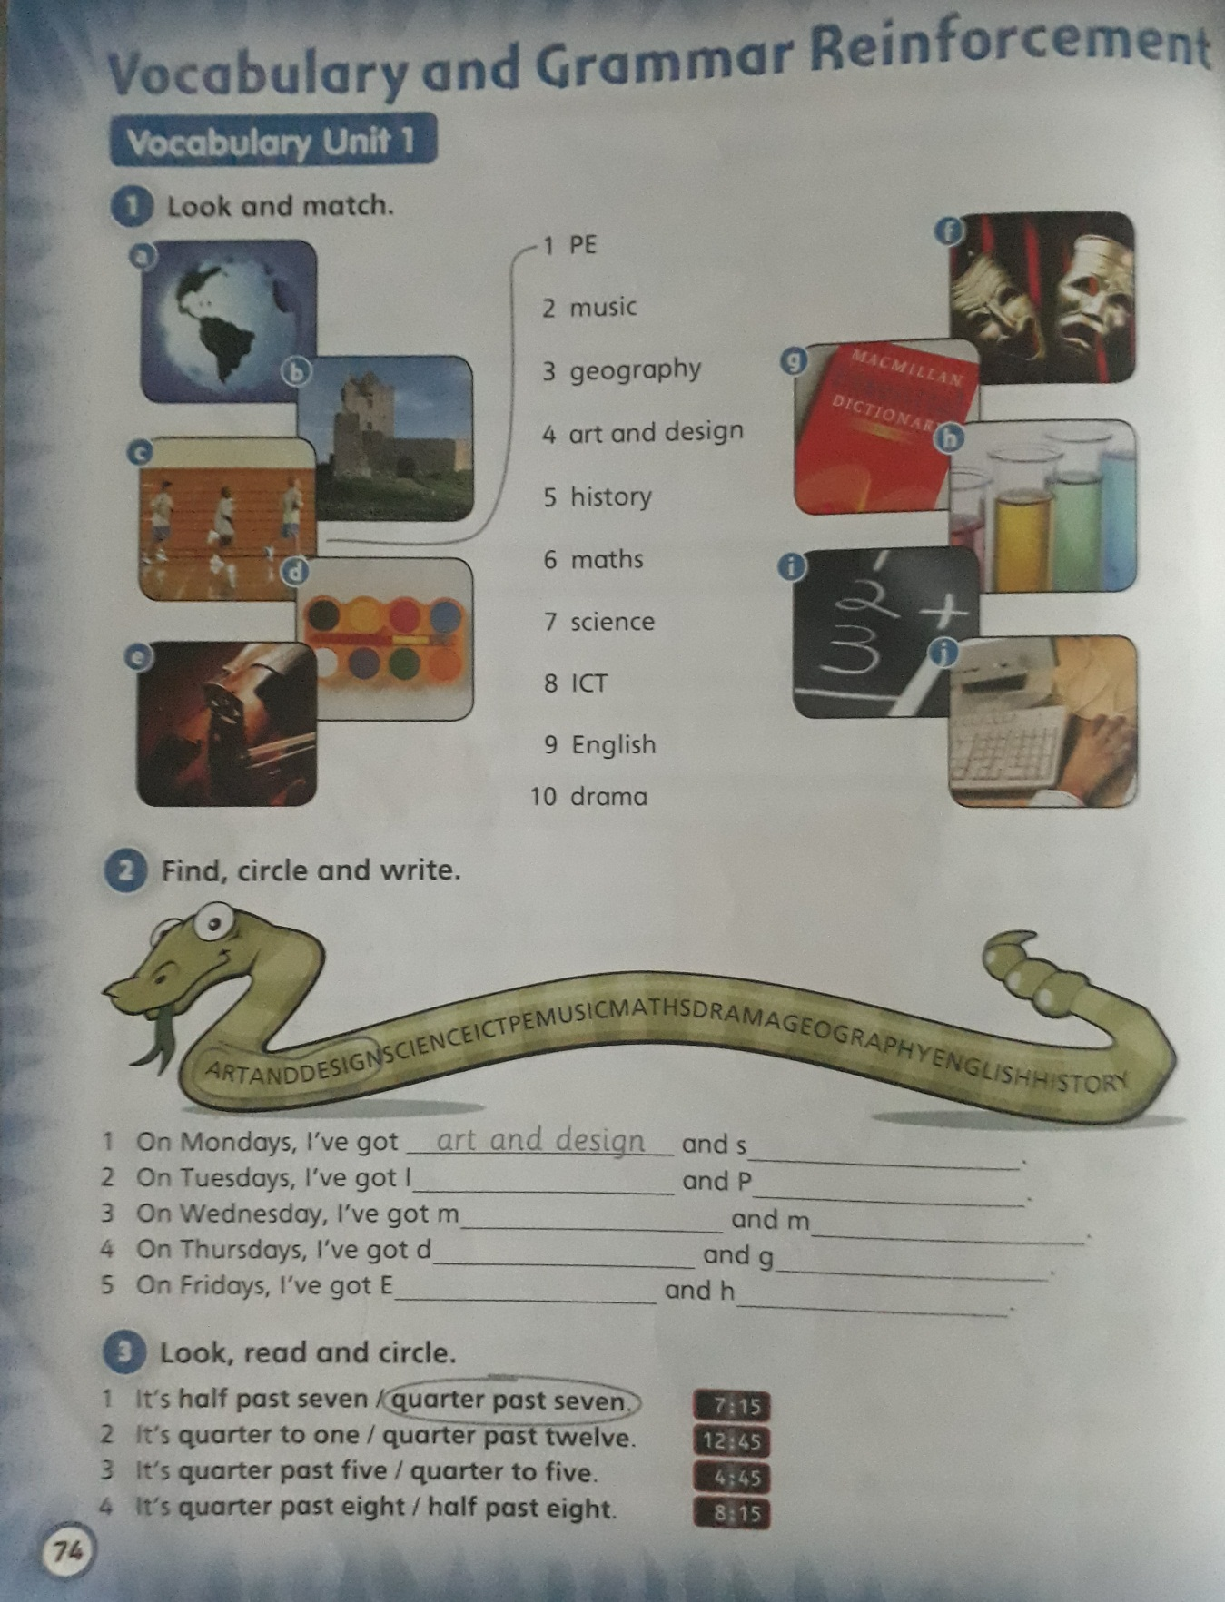

**Activity 1:**

1. **PE**

**b-**

**c-**

**d-**

**e-**

**f-**

**g-**

**h-**

**i-**

**j-**

**Activity 2:**

1. Art and design – science

2-

3-

4-

5-

**Activity 3**:

1. Quarter past seven

2-

3-

4-