Tuesday, 4th August

**Student’s Book (Page 21)**

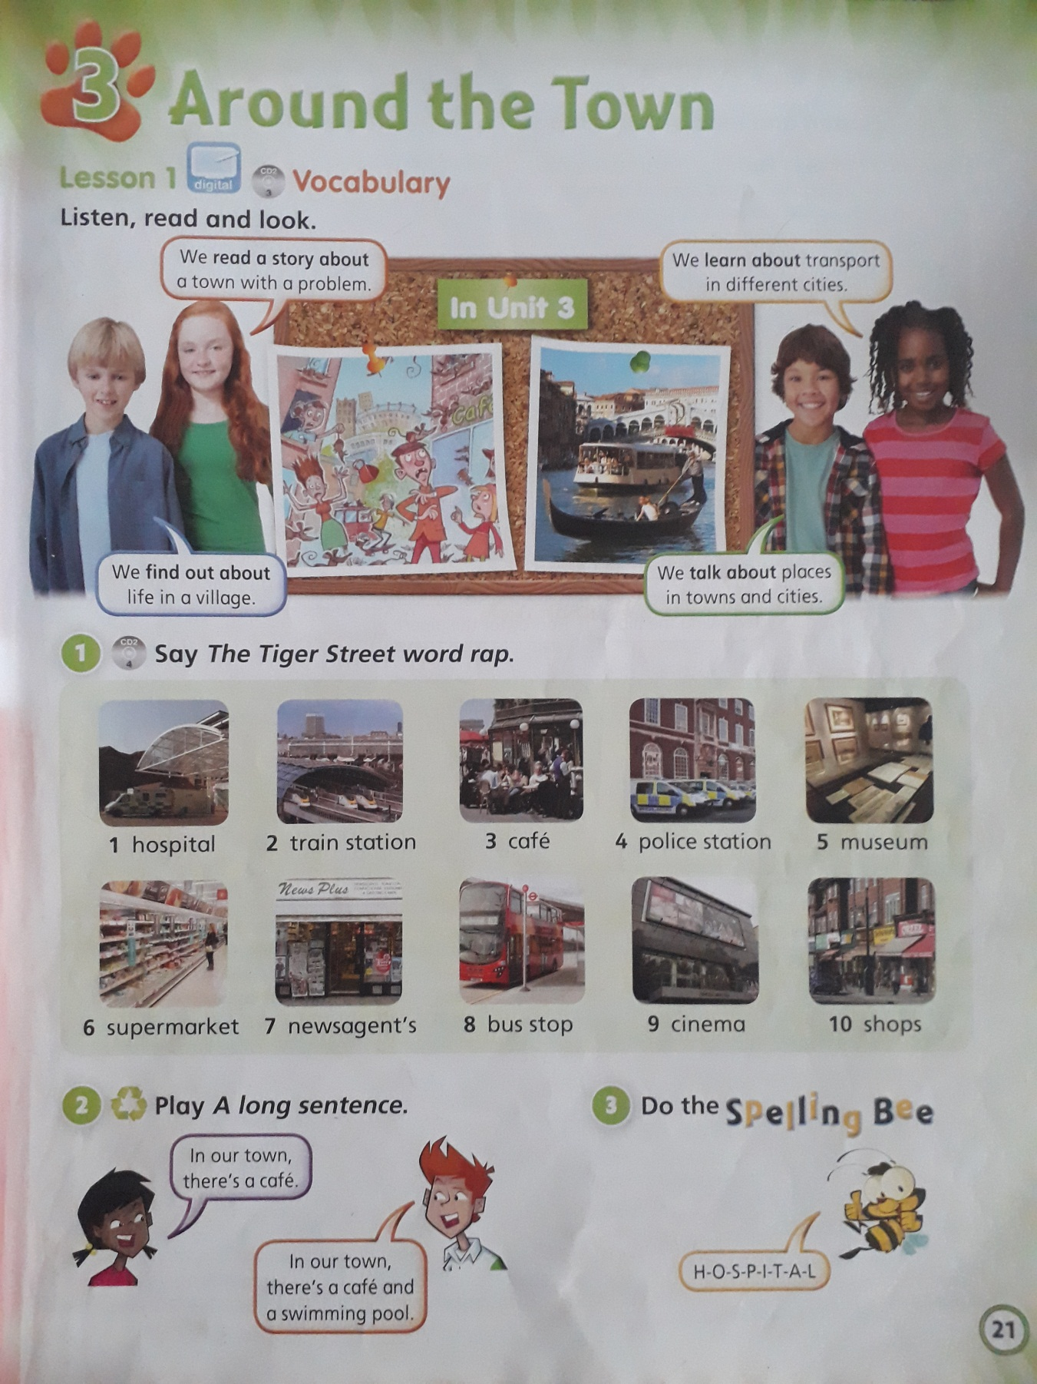

Listen to the “Word Rap” and say the words. (Audio 4)

**Booklet (page 21)**

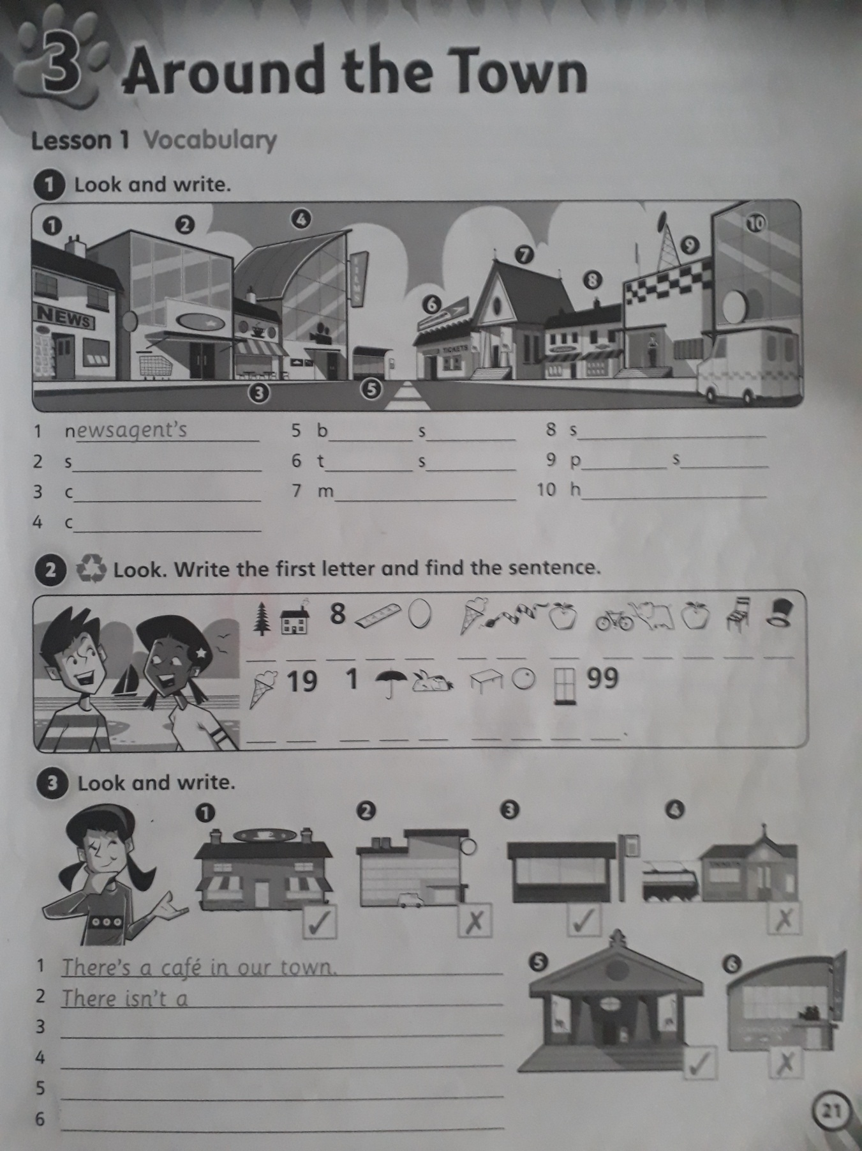

**REMEMBER!!!!**

**We use THERE IS to express existence.**

* **THERE IS (hay)**

X **THERE ISN’T (no hay)**

**Activity 1:**

1. Newsagent’s

**Activity 2:**

There is …….

**Activity 3:**

1. There is a café in our town.
2. There isn’t a …

3-

4-

5-

6-