Wednesday 6th, May

REVISION: UNIT 1 (Va con nota numérica)

***DO YOU REMEMBER?***

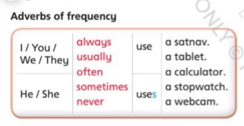

***IMPORTANT: WHEN THE PERSON IS HE OR SHE, WE ADD “S” OR “ES” TO THE VERB.***

***EG: He uses a calculator.***

***She watches TV***

***She goes shopping***

1. *Choose the correct option.* (Cambiale el color o resaltala)
2. Alex **take – takes** a photo on his tablet
3. I sometimes **use – uses** a webcam at home.
4. We never **watch – watches** TV in our bedrooms.
5. My sister usually **listen – listens** music in the evening.
6. *Order and write.*
7. *football / brother / plays / My / sometimes.*

*_____________________________________*

1. *go shopping / on Saturday / usually / We*
2. *uses / Mary / at school / often / a computer.*

1. *a tablet / never / with / take photos / I*
2. *Write DO or DOES.*
3. *______ you do your homework in your bedroom? Yes, I usually _____*
4. *______ your sister use a tablet? Yes, she sometimes ______*
5. *______ you watch films on a laptop? No, we never ______*
6. *______ your teachers use laptops at school? Yes, they often _____*