Tuesday, 6th October

**Booklet (Page 80)**

**Activity 1:**

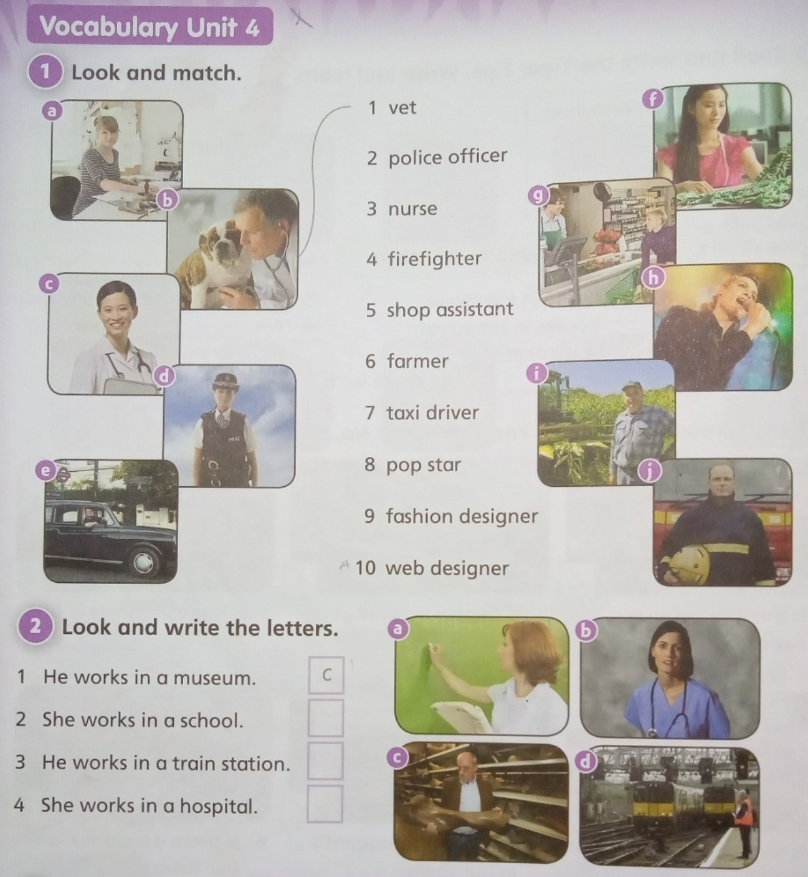

2. **1 vet**

**Activity 2:**

**

1. **C**

**Activity 3:** (Esta actividad NO está en el booklet de actividades)

