Colegio Modelo Marmol

6° Grade

Tuesday, 7 April 2020

**Tongue Twisters**

Let´s have some fun during quarantine !

Before starting, did you wash your hands?

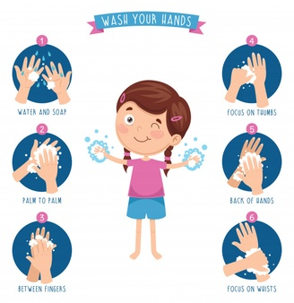

**Activity 1:** **Listen to the tongue twister and practise saying it.**

Read the following Tongue Twister and then listen to them following the links provided. You will find the correct pronounciation in the links ( to access them you have to click + ctrl on the link)

**Activity 2 (optional):** **How fast can you say it?**

When you feel ready to repeat them, choose 1 and film yourself reading it. Last but not least, send it to your teacher. If you are not a camara fan, you can record your production to be shared with your class.

<https://learnenglishkids.britishcouncil.org/tongue-twisters/big-black-bug>

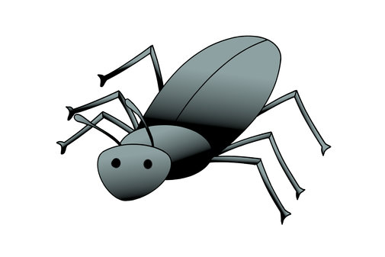

*'A big black bug bit a big black dog on his big black nose.'*

<https://learnenglishkids.britishcouncil.org/tongue-twisters/the-big-bug-bit-the-little-beetle>

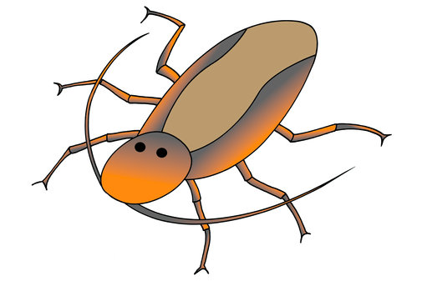The big bug bit the little beetle, but the little beetle bit the big bug back.'

<https://learnenglishkids.britishcouncil.org/tongue-twisters/two-witches>

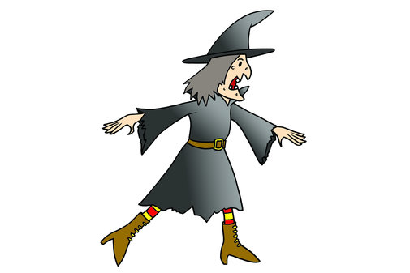'If two witches were watching two watches, which witch would watch which watch?'

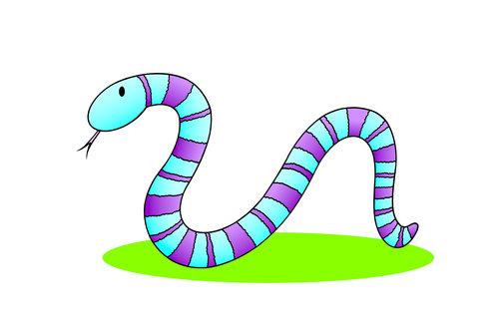<https://learnenglishkids.britishcouncil.org/tongue-twisters/tricky-frisky-snake>

'A tricky, frisky snake with sixty super scaly stripes.'

<https://learnenglishkids.britishcouncil.org/tongue-twisters/fuzzy-wuzzy>

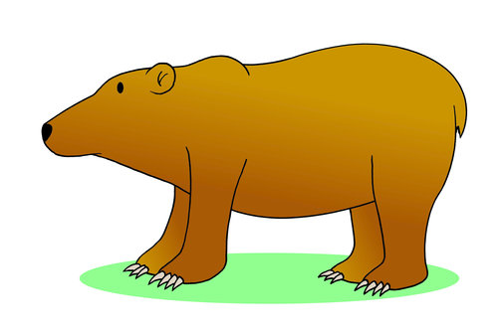Fuzzy wuzzy was a bear. Fuzzy wuzzy had no hair. Fuzzy wuzzy wasn't very fuzzy, was he?'

<https://learnenglishkids.britishcouncil.org/tongue-twisters/whether-the-weather>

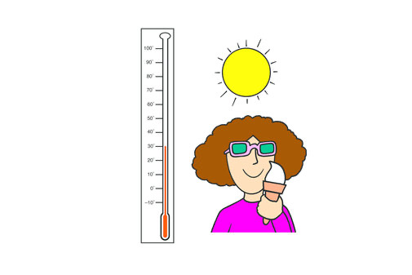Whether the weather is warm, whether the weather is hot, we have to put up with the weather, whether we like it or not.'