Tuesday, 7th July

**Booklet** (page 76)

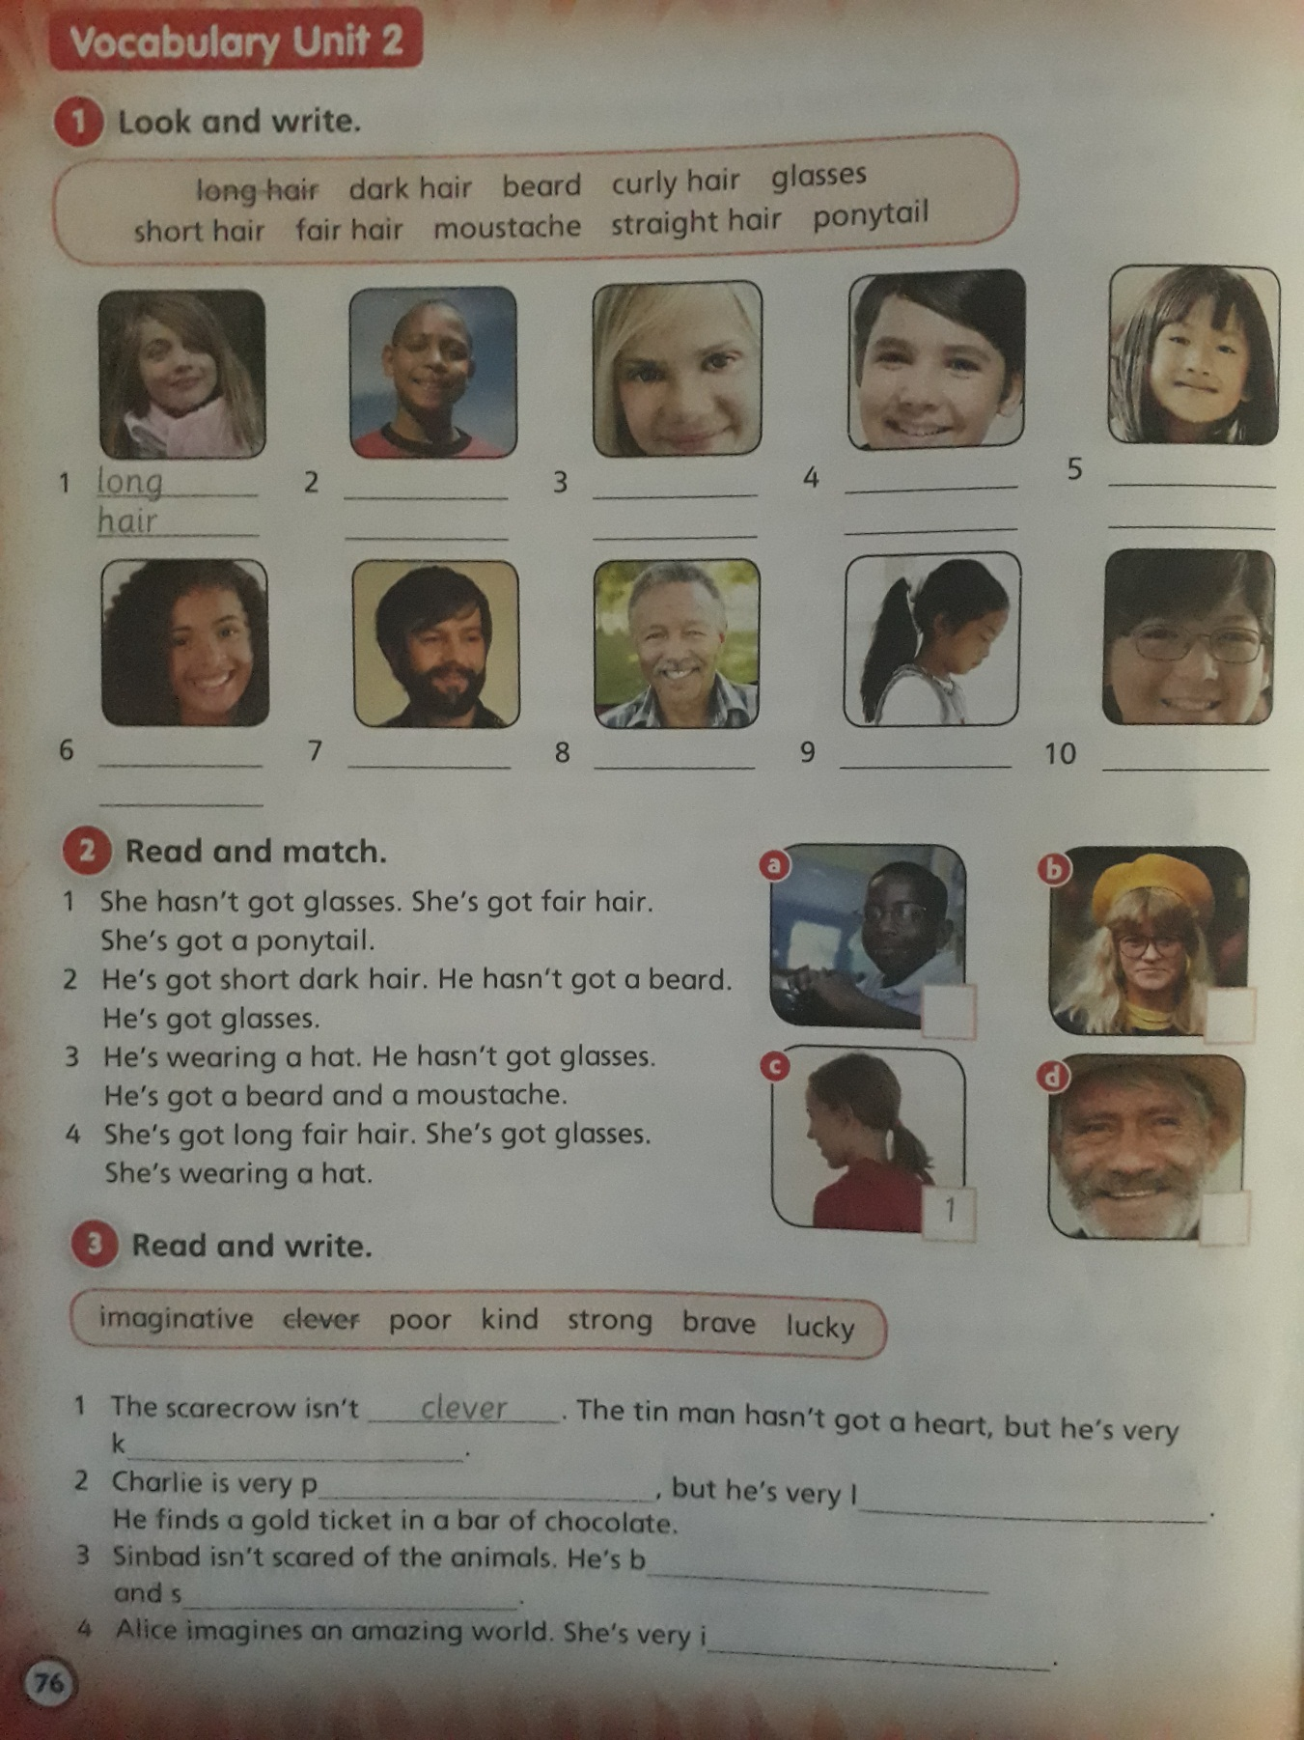

**Activity 1:**

1. Long hair

2-

3-

4-

5-

6-

7-

8-

9-

10-

**Activity 2:**

1. 1

**Activity 3:**

1. Clever/ K---
2. P---/ l----
3. B----/ s-----
4. I----------