Tuesday, 10th November

**VOCABULARY : “Things we like doing”**

**Booklet (page 82)**

**Activity 1:** Match the activities with the correct pictures.

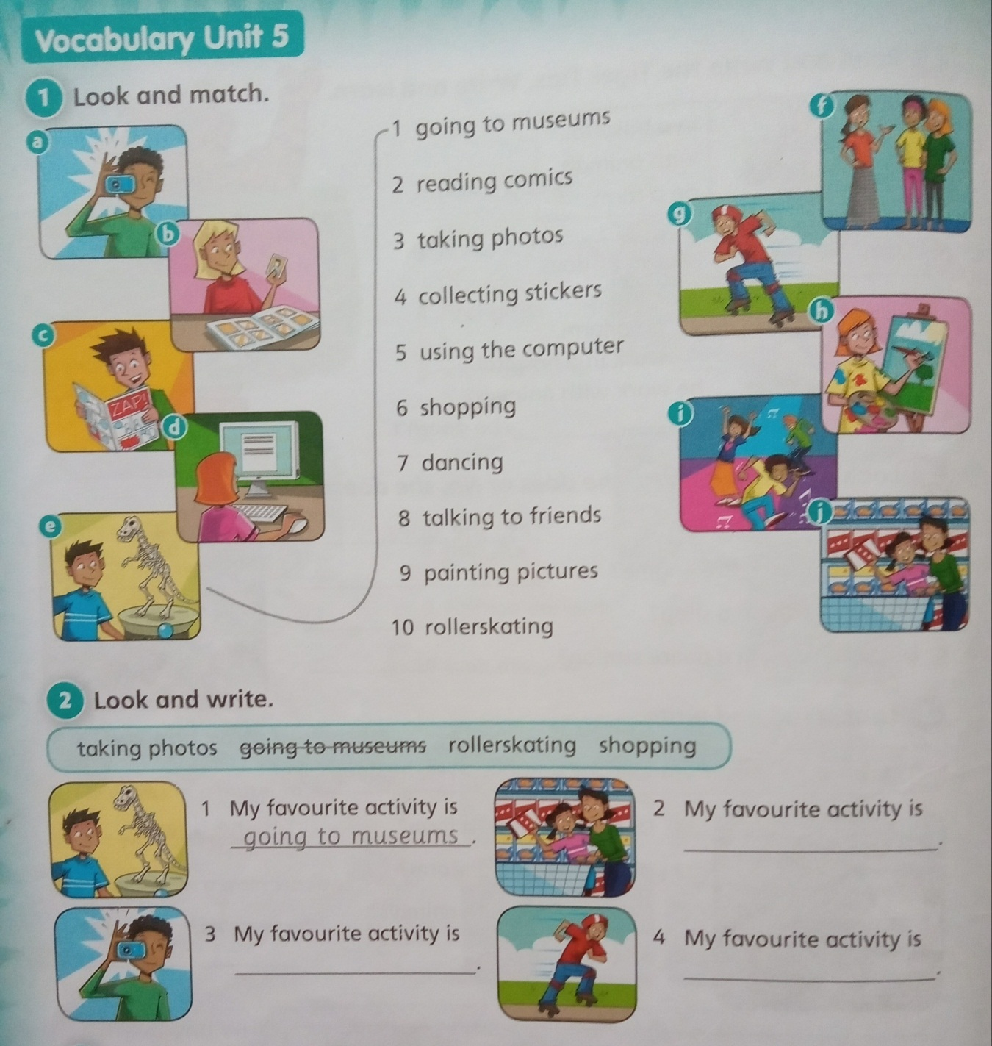

1. **e**

**Activity 2:**  Complete the sentences with the correct activity.



1. going to museums

**Student’s Book (pages 38 – 39)**

Vamos a leer la historia nuevamente para recordarla y luego resolvemos la actividad de True (verdadero) o False (falso)

1. Read the story: ***“A great invention”***
2. Write **TRUE** or **FALSE**
3. Joseph Merlin is an inventor.
4. He likes collecting stickers.
5. He likes making musical instruments.
6. He receives an invitation to a birthday party.
7. He breaks a mirror.

