Colegio Modelo Marmol

6° Grade

Name and surname:________________________________________________________________

Grade:_______________

Tuesday, 14 April 2020

Before starting, did you wash your hands?

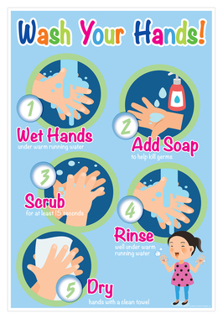

**Tongue Twisters**

**Do you remember?**

Complete the tongue twisters. Then check with the links provided ( to access them you have to click + ctrl on the link)

1. 'A big ____________ bug bit a big black__________ on his big black _______________.'

<https://learnenglishkids.britishcouncil.org/tongue-twisters/big-black-bug>

1. The big bug bit the little ___________, but the little beetle bit the ____________ bug back.'

<https://learnenglishkids.britishcouncil.org/tongue-twisters/the-big-bug-bit-the-little-beetle>

1. 'If two ____________ were watching two _________, which witch would watch which watch?'

<https://learnenglishkids.britishcouncil.org/tongue-twisters/two-witches>

1. 'A tricky, frisky ___________ with sixty super scaly _____________.

<https://learnenglishkids.britishcouncil.org/tongue-twisters/tricky-frisky-snake>

1. ‘____________lorry, _____________ lorry’

<https://learnenglishkids.britishcouncil.org/es/tongue-twisters/red-lorry-yellow-lorry>

1. ´Fuzzy wuzzy was a___________. Fuzzy wuzzy had no hair. Fuzzy wuzzy wasn't ________________ fuzzy, was he?'

<https://learnenglishkids.britishcouncil.org/tongue-twisters/fuzzy-wuzzy>

1. Whether the _____________ is warm, whether the weather is hot, we have to put up with the weather, _____________________ we like it or not.'

<https://learnenglishkids.britishcouncil.org/tongue-twisters/whether-the-weather>

1. "Zebra´s ____________ and zebras __________."

<https://learnenglishkids.britishcouncil.org/es/tongue-twisters/zebras-zig>

1. ‘Eleven ___________ licked _____________ little liquorice lollipops.'

<https://learnenglishkids.britishcouncil.org/es/node/17919>

1. Toy ______________, Toy phone, ____________ phone..."

<https://learnenglishkids.britishcouncil.org/es/tongue-twisters/toy-phone>