Tuesday, 14th April

Let´s learn **school subjects**!!

1. Look at the pictures.
2. Read the words.

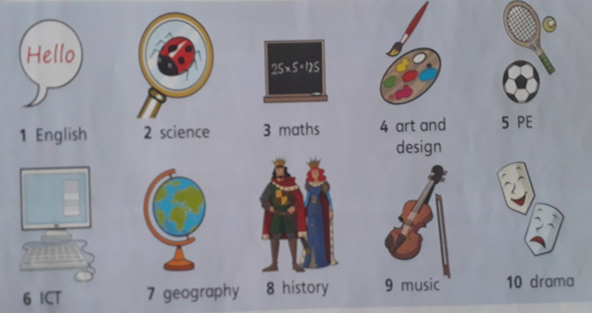

1. What is your favourite school subject?

My favourite school subject is……………….

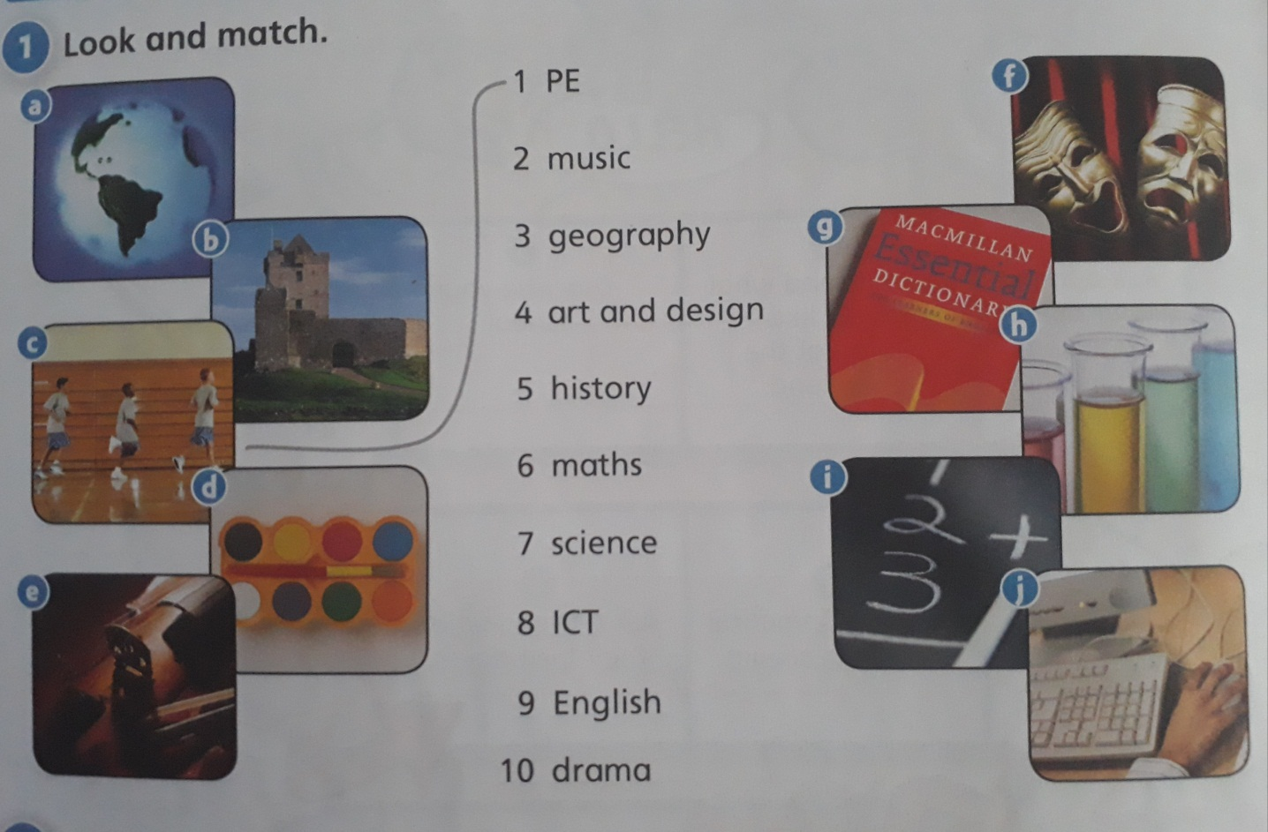

1. Look and match the pictures with the correct word. (Escribe las respuestas debajo siguiendo el ejemplo)

Example:

C – 1 P.E.

A - F-

B- G-

C- 1 P.E. H-

D- I-

E- J-