Thursday, 14th May

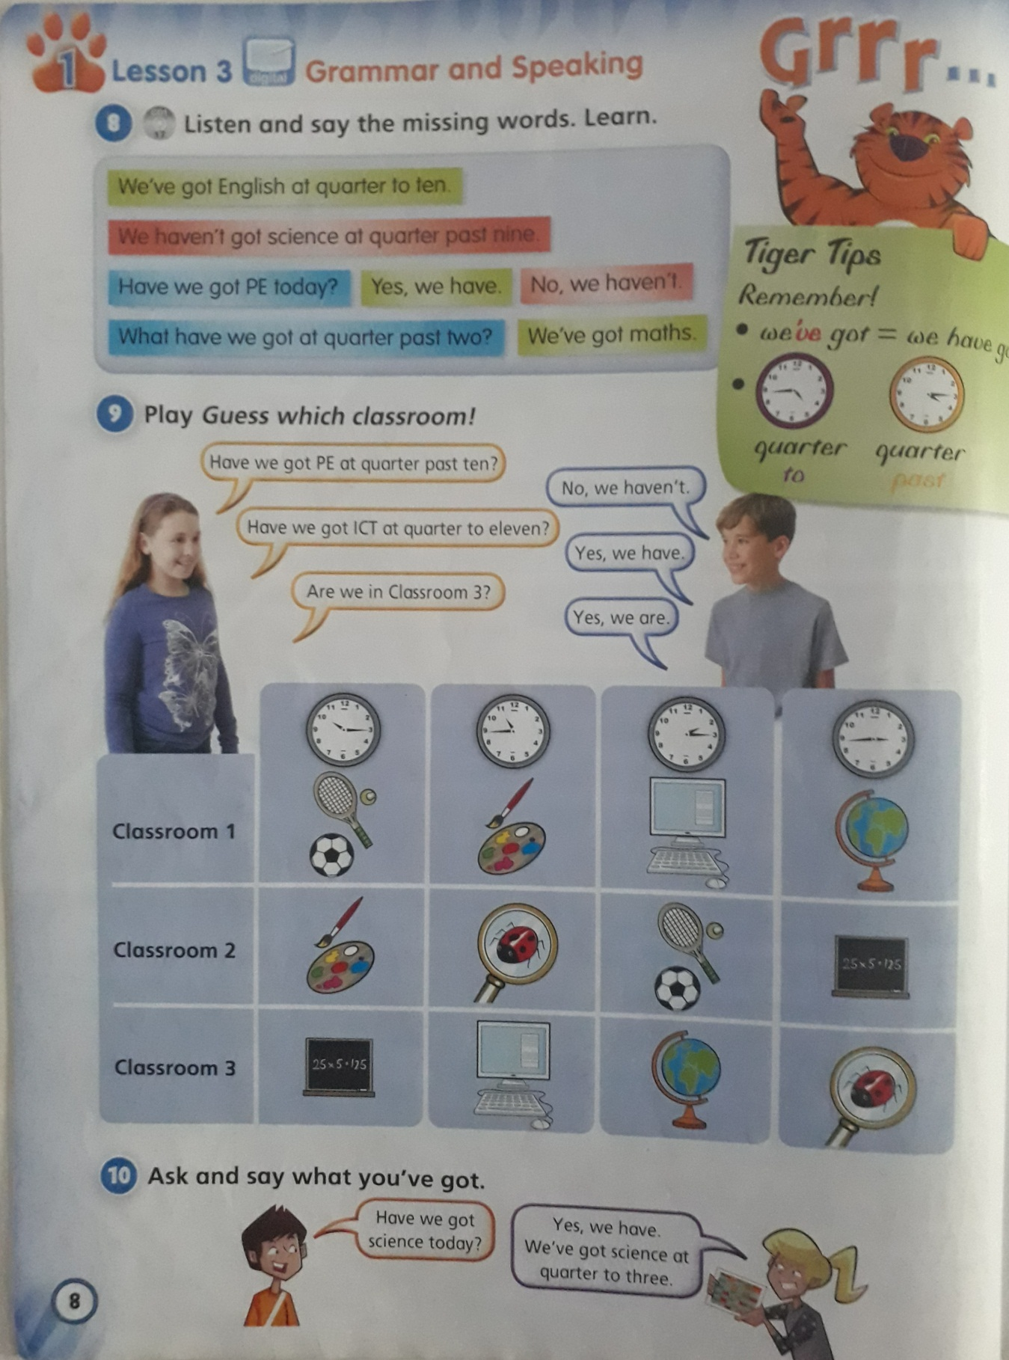

1. Look at the chart in activity 9 and guess the classroom!!!

**Example**

We have ICT at quarter to eleven. We haven´t got PE at quarter past ten. ***Classroom3***

1. We have geography at quarter to three. We haven’t got art and design at quarter past two.
2. We have art and design at quarter past ten. We haven´t got science at quarter to three.
3. We have maths at quarter past ten. We haven’t got PE at quarter to eleven.
4. Look at the chart again and choose the correct answer.

CLASSROOM 1:

Have we got PE at quarter past ten? Yes, we have. / No, we haven’t.

Have we got ICT at quarter to three? Yes, we have. / No, we haven’t.

CLASSROOM 2:

Have we got science at quarter past two? Yes, we have. / No, we haven’t.

Have we got maths at quarter to three? Yes, we have. / No, we haven’t.

CLASSROOM 3:

Have we got maths at quarter to eleven? Yes, we have. / No, we haven’t.

Have we got geography at quarter past two? Yes, we have. / No, we haven’t.