Tuesday, 14th July

**Booklet** (Page 77)

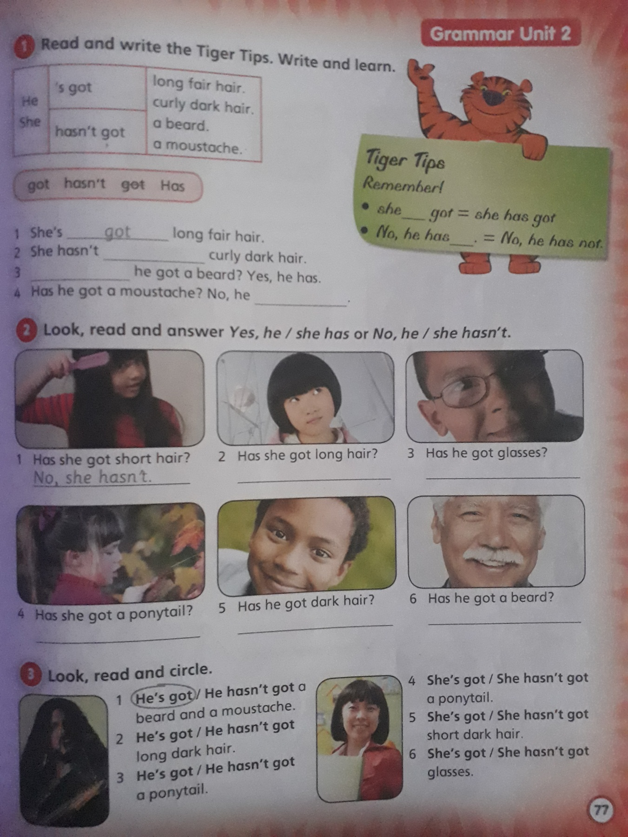

**Activity 1:**

1. got

2-

3-

4-

**Activity 2:**

1. No, she hasn’t.

**2-**

**3-**

**4-**

**5-**

**6-**

**Activity 3:**

1. He’s got

2-

3-

4-

5-

6-