Today is Thursday 16th, April

What’s the weather like? It’s________________

**GOOD MORNING KIDS!!!!** We are going to work with **FREE TIME ACTIVITIES.**

***Pay attention!!!***

1. **Read and write the name in the sentences.**

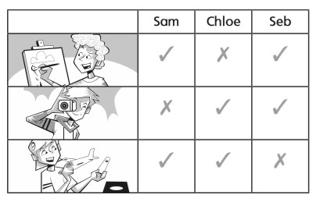

* **Hi! My name is _____________.**

**I paint pictures and take photos. I don’t make things.**

* **Hi! My name is______________.**

**I paint pictures and make things. I don´t take photos.**

* **Hi! My name is ______________.**

**I don´t paint pictures. I take photos and make thing.**

**Now, pay attention again!!!!**

**AFFIRMATIVE SENTENCES:**

**I PAINT PICTURES**

**I TAKE PHOTOS**

**I GO ON EXCURSIONS**

**NEGATIVE SENTENCES: A las negativas les agrego el DON’T**

**I DON´T MAKE THINGS**

**I DON’T USE A COMPUTER**

**I DON´T DO SPORTS**

**Ahora solitos!!!**

1. **Look and write. (Hace las 4 oraciones que restan. 2 afirmativas y 2 negativas, como en el ejemplo)**

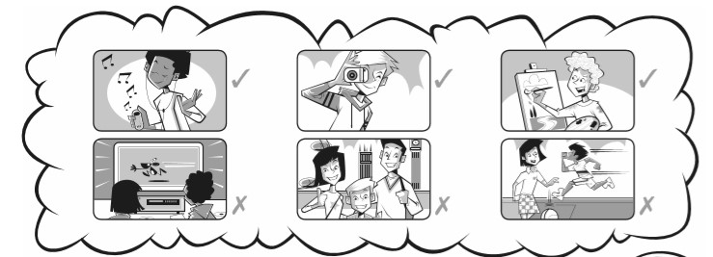

**Eg: I listen to music**

**I don´t watch films**