Student name:

Colegio Modelo Marmol

Unit 1 Revision

Group : 6° Date : Tuesday June 16th

LISTENING



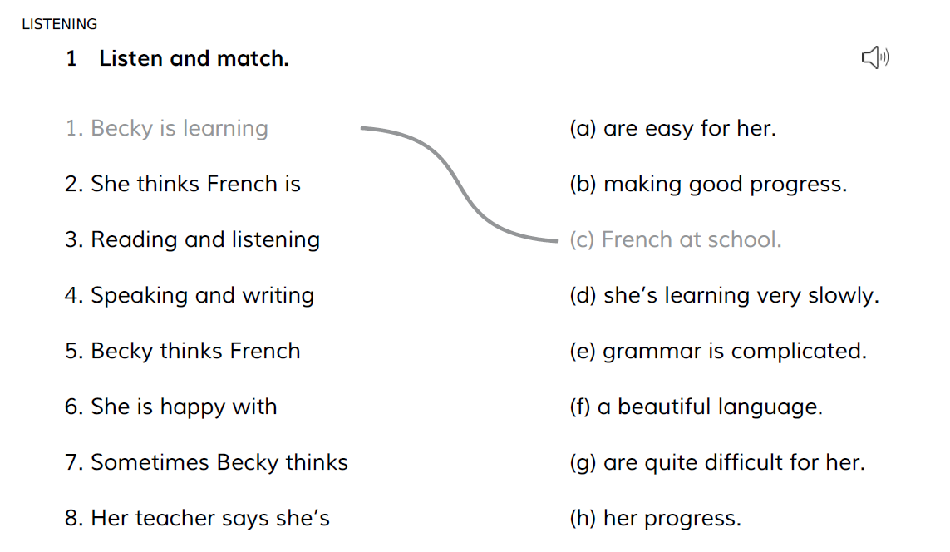

READING

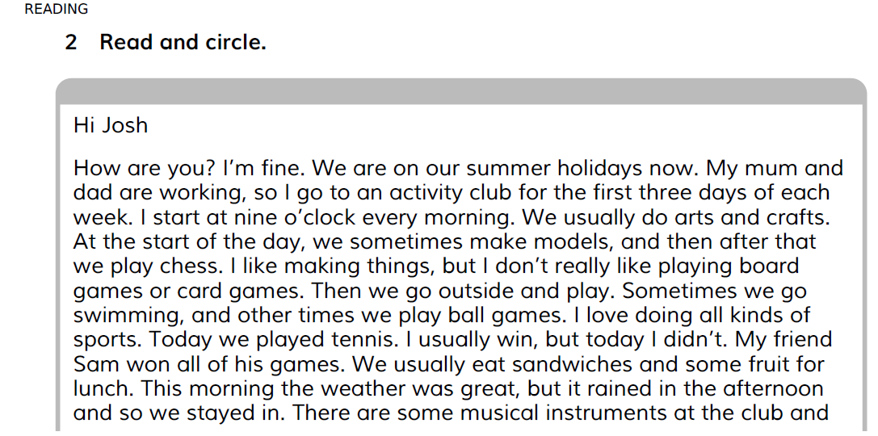

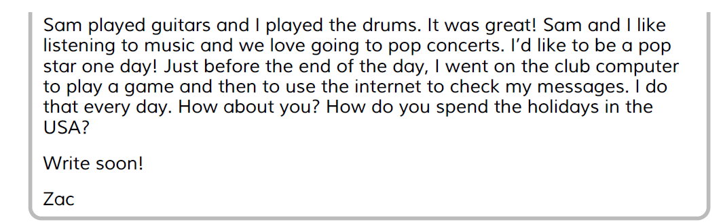

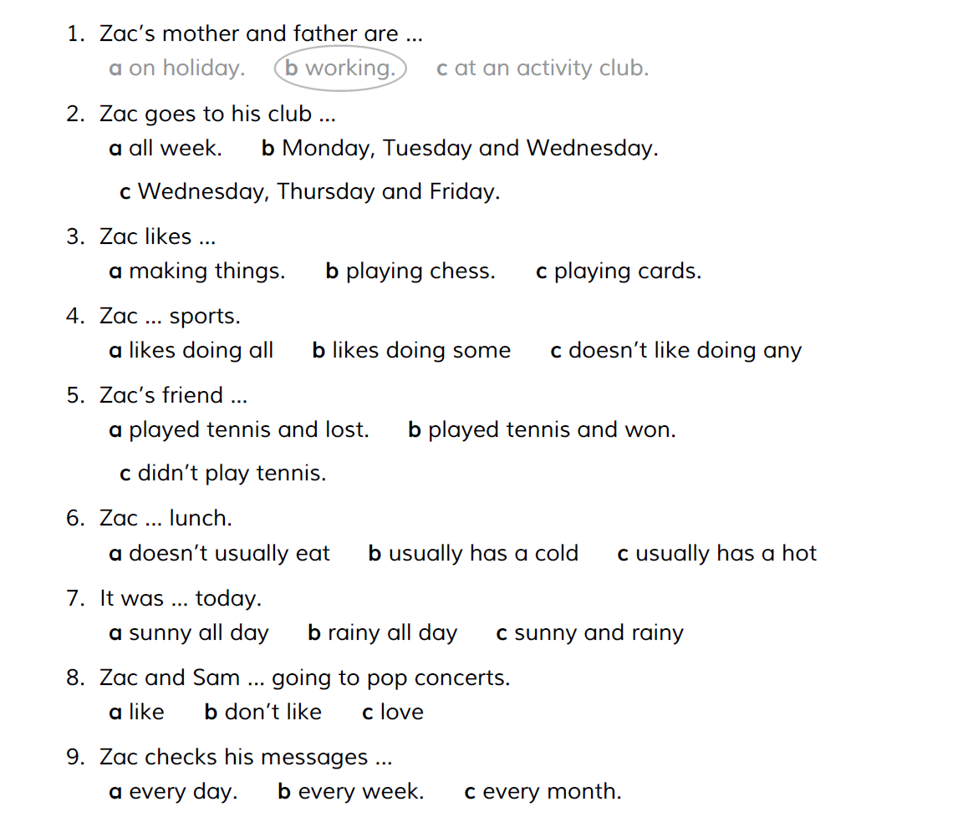

WRITING

3. Look and complete the sentences. Use the correct form of these activities.

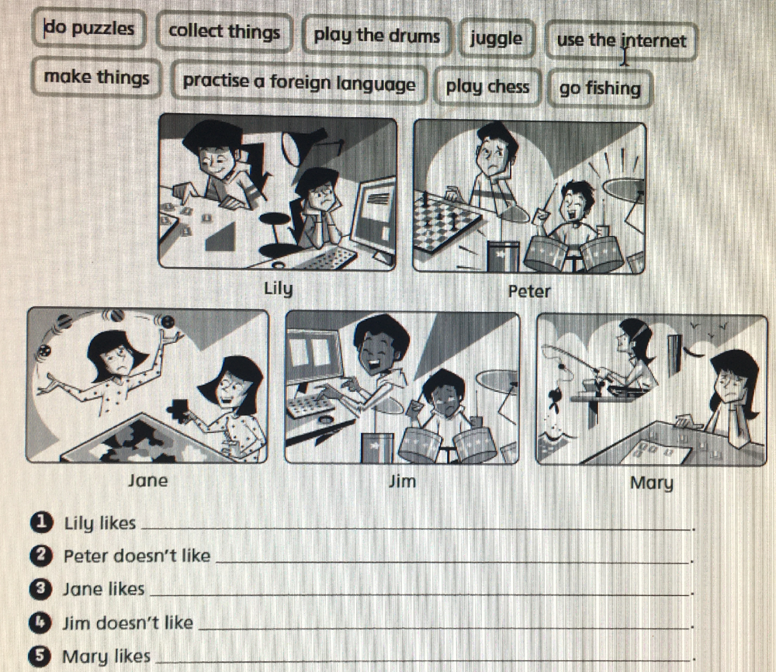

Assessment (Valoración del docente)

|  |  |  |  |
| --- | --- | --- | --- |
| OBJECTIVES | WIDELY ACHIEVED OBJECTIVES (objetivos logrados ampliamente) | OBJECTIVES ACHIEVED (objetivos logrados) | OBJECTIVES IN THE PROCESS OF BEING ACHIEVED  (objetivos en proceso de ser logrados) |
| READING COMPREHENSION (lectura comprensiva): ………. |  |  |  |
| GRAMMAR IN USE (gramática aplicada): ……. |  |  |  |
| WRITING (escritura) (guiada/creativa/semiguiada…): …. |  |  |  |
| LISTENING COMPREHENSION (audición comprensiva): ….. |  |  |  |
| ORAL (oralidad) |  | | |