COLEGIO MODELO MARMOL

6º B / C

MONDAY, 18 MAY 2020

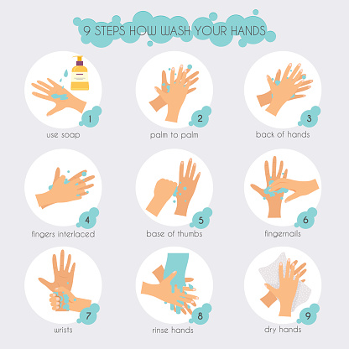

INTONATION TIME!

( SB PAGE 9)

Listen and repeat



Listen and say True or False



AB PAGE 8

<https://www.liveworksheets.com/if348074tv>

