Today is Thursday 19th, March

It is___________(RAINY- CLOUDY – SUNNY)

Match the colours

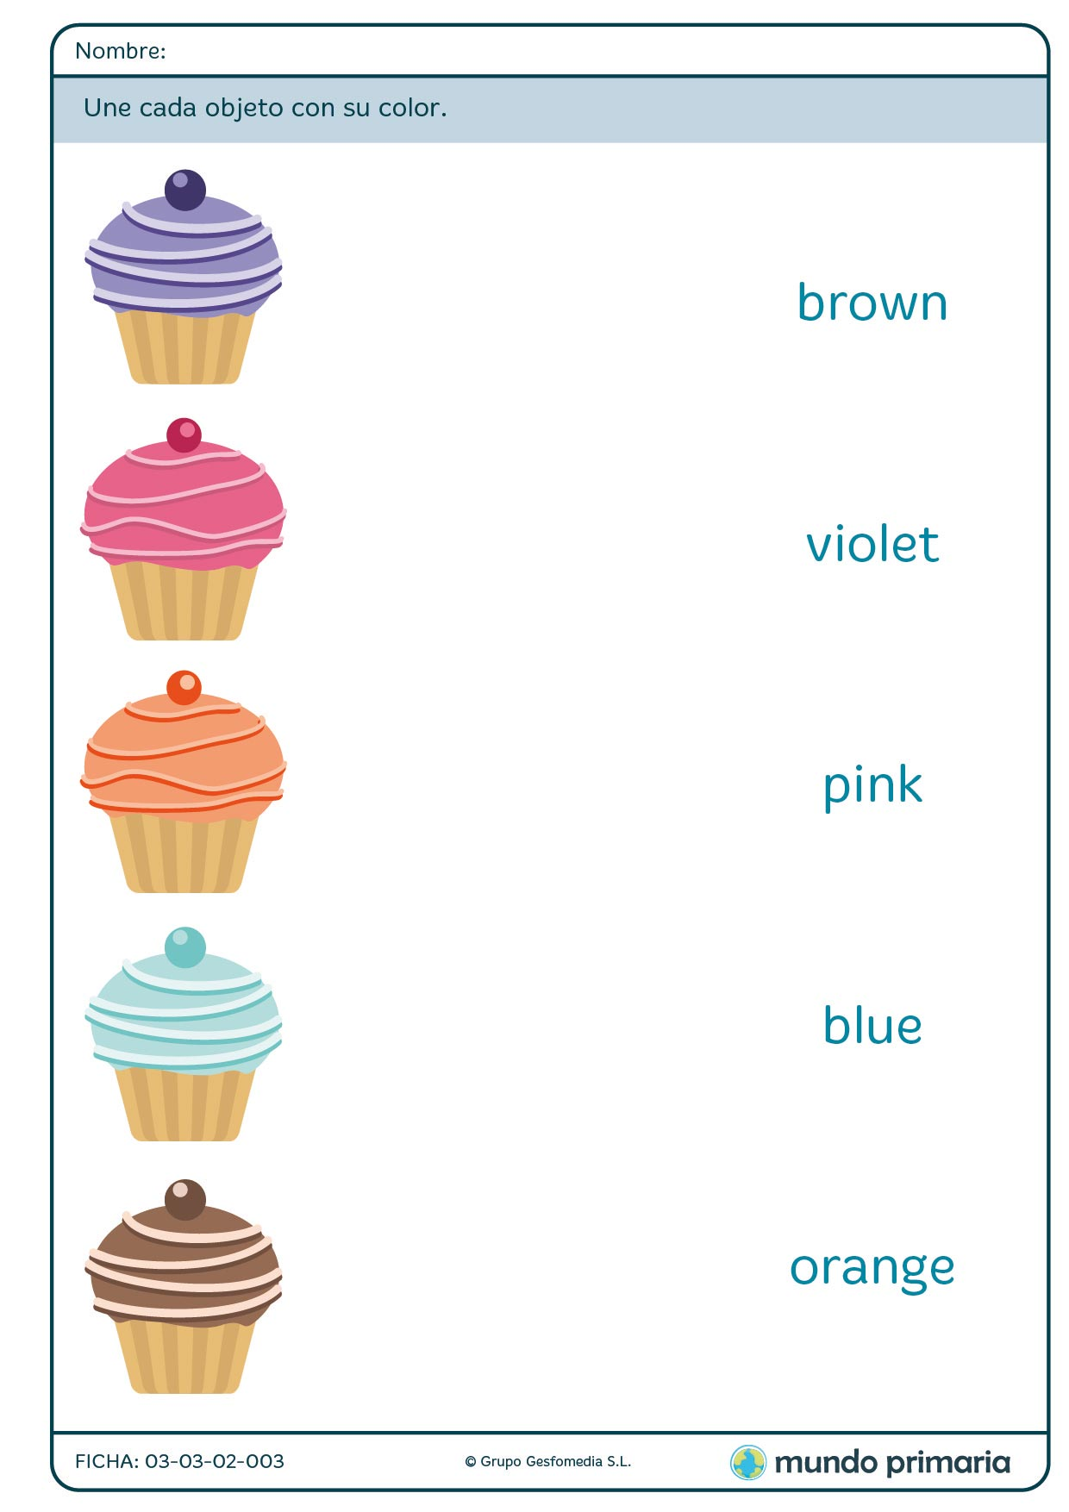

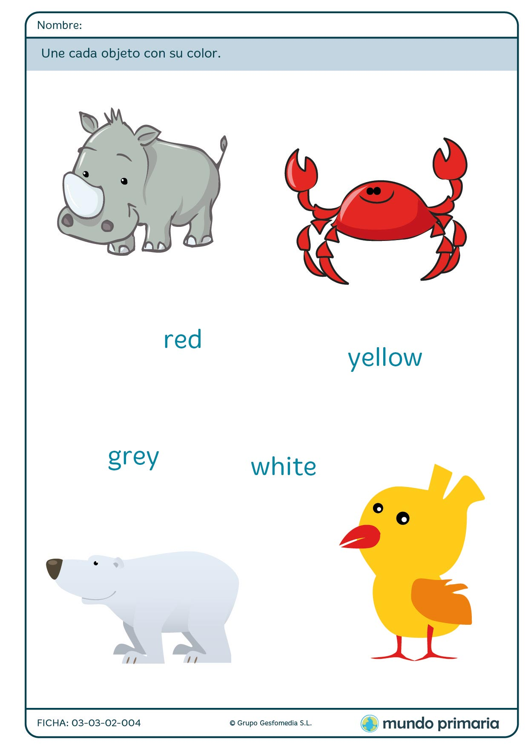

*LET’S WORK, KIDS!!*

*SEE YOU SOON…. MISS GERAL*

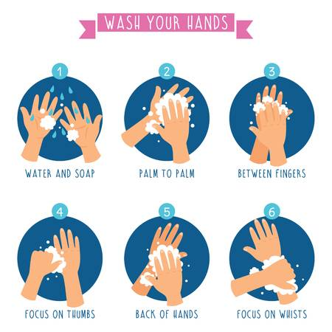

**REMEMBER…**