Wednesday 20th, May

GOOD MORNING EVERYONE!!! HOW ARE YOU TODAY?

WE ARE GOING TO REVISE **PRESENT CONTINUOUS.** READY?

* WE USE IT TO TALK ABOUT THINGS THAT **ARE HAPPENING NOW**
* WE MAKE IT WITH **VERB TO BE + VERB+ ING**
* VERB TO BE: AM – IS – ARE

I ---🡪 AM

SHE- HE- IT ---🡪 IS

YOU- WE- THEY ---🡪 ARE

* EG: I AM CYCLING
* SHE IS LISTENING TO MUSIC
* YOU ARE WEARING A HELMET

1. NOW… Look at the picture and write some sentences. (Elegí solo 5 personas y realizá las oraciones. Te dejo un ejemplo)

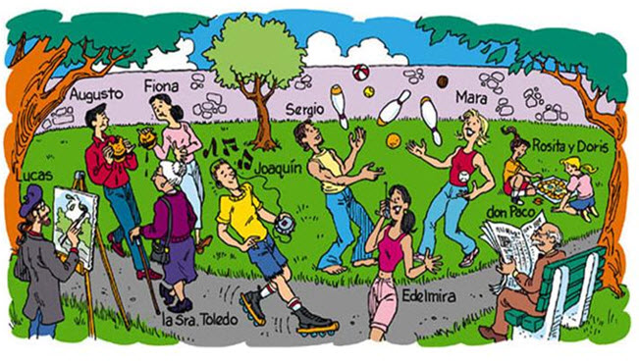

EG: Sergio and Mara are juggling

5. Solve these exercises. Use the word in the box. (Usa las palabras que tenes en sombreadas)

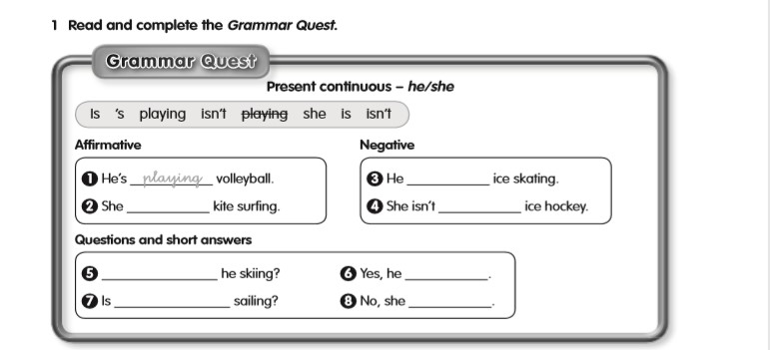

1. **AFFIRMATIVE**
2. Playing

**NEGATIVE**



**QUESTIONS AND SHORT ANSWERS**

5. Read and choose the correct option. (Cambiale el color o subrayá la correcta)
6. I AM / IS playing ice hockey
7. He IS / AM playing volleyball
8. She ISN’T/ AM NOT ice skating
9. I AM NOT/ ISN’T kitesurfing
10. ARE/ IS you sledging?
11. ARE/ IS she skiing?