Thursday, 20th August

**Book** (Page 26)

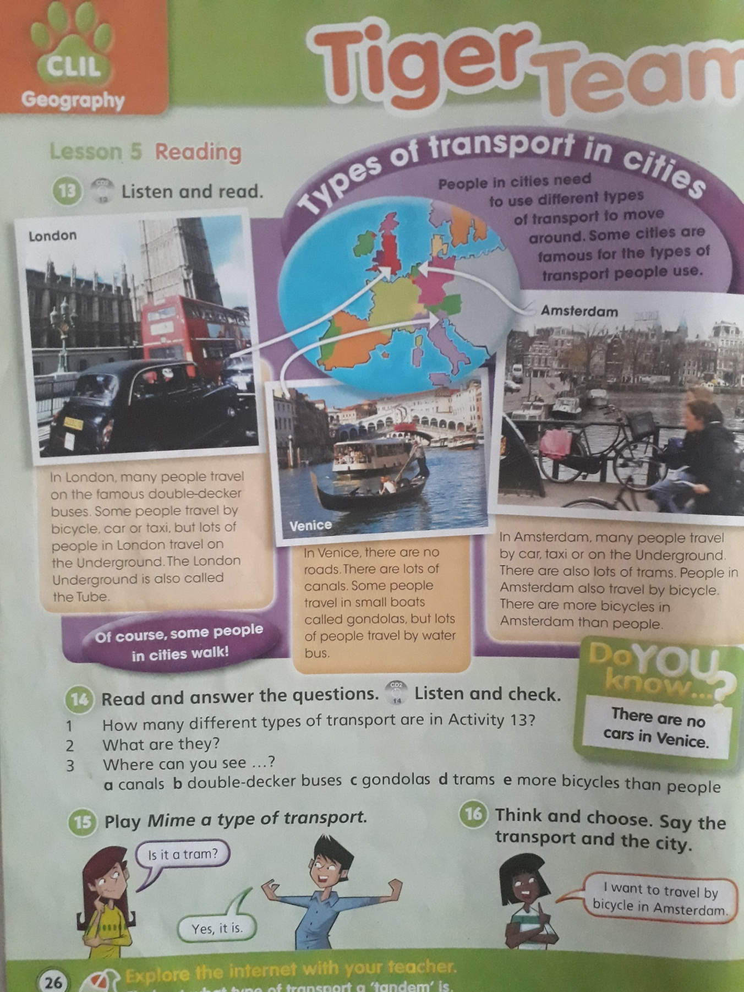

Read the text and solve the activities in the **BOOKLET** (Page 25)

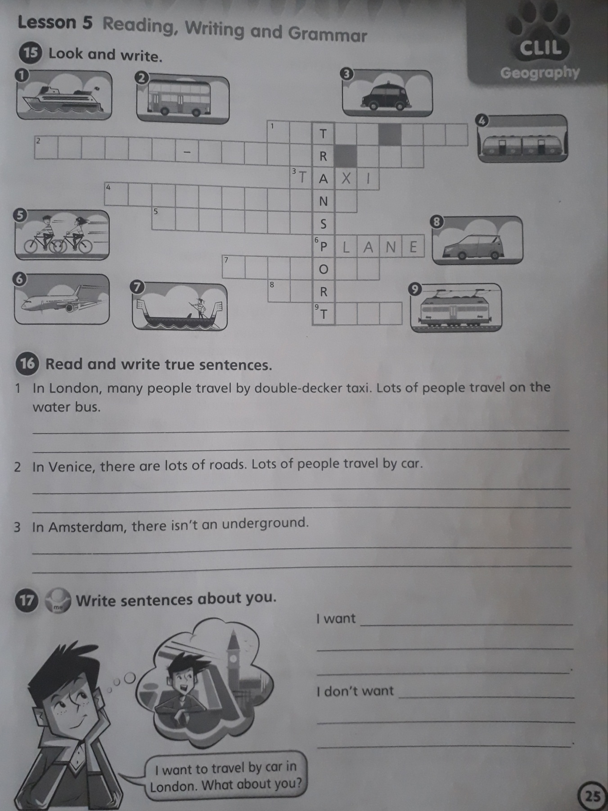

**Activity 15:**

**1-**

**2-**

**3- taxi**

**4-**

**5-**

**6- plane**

**7-**

**8-**

**9-**

**Activity 16:**

**1-**

**2-**

**3-**

**Activity 17:**

I want ……………………………………..

I don’t want …………………………….