Today is Tuesday 21st, April

What’s the weather like? It’s ________________

PARTS OF THE HOUSE

1. Look and write  the numbers.

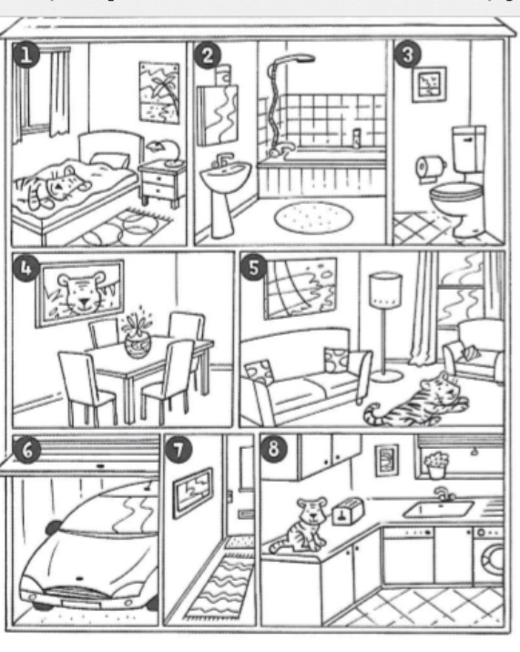

1. It is in the bathroom

**2**

1. It is in the living room
2. It is in hall
3. It is in the dining room
4. It is in the garage
5. It is in the bedroom
6. It is in the kitchen
7. It is in the toilet
8. Count the TIGERS in the picture. Write the number *(Contá los tigres que hay en la casa y escribí el número)*



HAVE A NICE TUESDAY!!!!