COLEGIO MODELO MARMOL
GRADE: 6ª B & C
THURSDAY, 16 APRIL 2020
Countries
Play time!
This is a simple game for learning English vocabulary. You drag the images to match the words and then click on the words to match the images.
The aim of this game is to practice vocabulary about Countries and it presents images, text and audio.
There are 2 parts to this game. In the first part, you are show sets of 3 or 4 images. You then have to click and drag these images to the matching words. When the image is moved to the correct word, it will stick there and the audio plays. Once you have matched 10 images, you proceed to the next part. In the second part, you are presented with a big image and you are required to click on the corresponding word from a set of 3 below. You keep on clicking until you get the right word and when you do, the audio is played. When you have done this for 10 items, you go back to the first part and then this repeats 2 or 3 times.
(Vamos a jugar online con los países. Sigan los pasos)
Follow the steps:
1 | https://www.gamestolearnenglish.com/
2 | 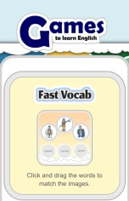
3 | 
4 | 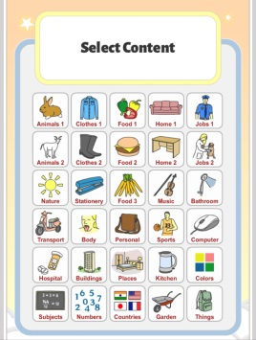
5 | Click COUNTRIES
6 | PLAY TIME!  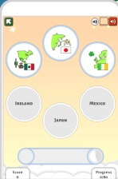
https://www.gamestolearnenglish.com/fast-english/

