Thursday 23rd, April

What’s the weather like today? It’s_______________

MEETING THE CHARACTERS…

**JAY** – **SUE** – **TIGER**

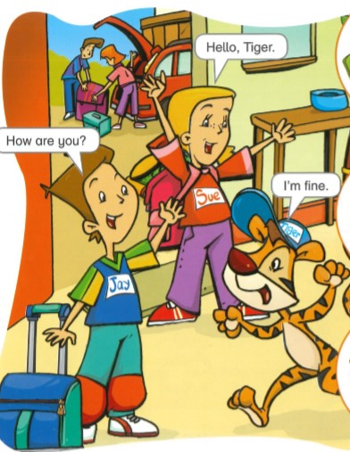

**LY**

We are going to listen to a story…. Ready?

<https://www.youtube.com/watch?v=bzKclBQHHrI>

1. Look and write

4

3

2

1

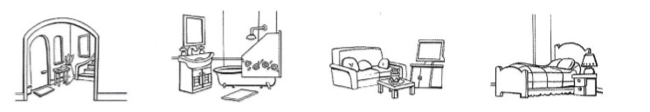

1. H_ _ _
2. B_ _ _ _ _ _ _
3. L _ _ _ _ _ R _ _ _
4. B_ _ _ _ _ _
5. Write. *¿En qué parte de la casa están cada uno?*

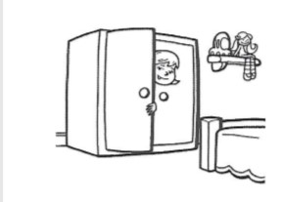LY IS IN THE [______________](https://www.youtube.com/watch?v=bzKclBQHHrI)

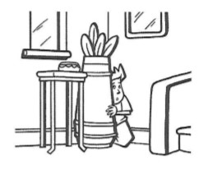JAY IS IN THE _______________

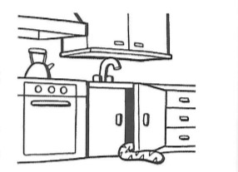TIGER IS IN THE_____________