Thursday 23rd, April

What’s the weather like today? It’s________________________.

MEETING THE CHARACTERS

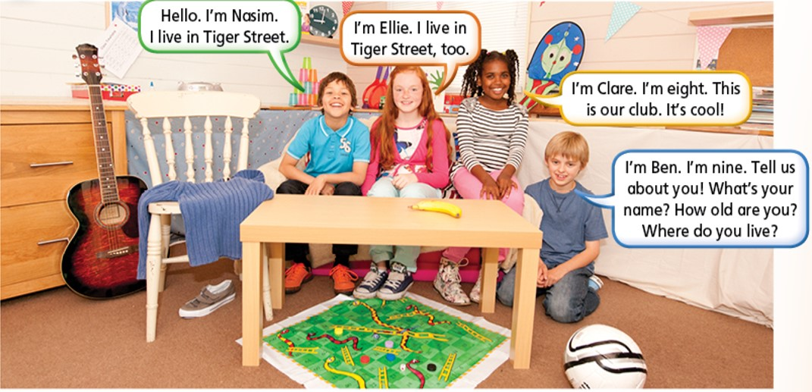

**LISTEN TO THE STORY… “A laptop for the Club”**

[**https://www.youtube.com/watch?v=WCvwTfw0RJ4&t=27s**](https://www.youtube.com/watch?v=WCvwTfw0RJ4&t=27s)

**Si te parece difícil entender lo que la historia dice, en vez de verla, podes leerla (te la dejo aquí abajo o si tenes el libro, la podes ver ahí). El video y la historia son lo mismo, vos elegí lo que te sirva más para entenderla mejor.**

**Some words to help you** (Aparecen en la historia)

**Shed: cobertizo thief: ladrón**

**Magazine: revista Ladder: escalera**

**Perhaps: Tal vez runs away: huir- escapar**

**Falls over: caer**

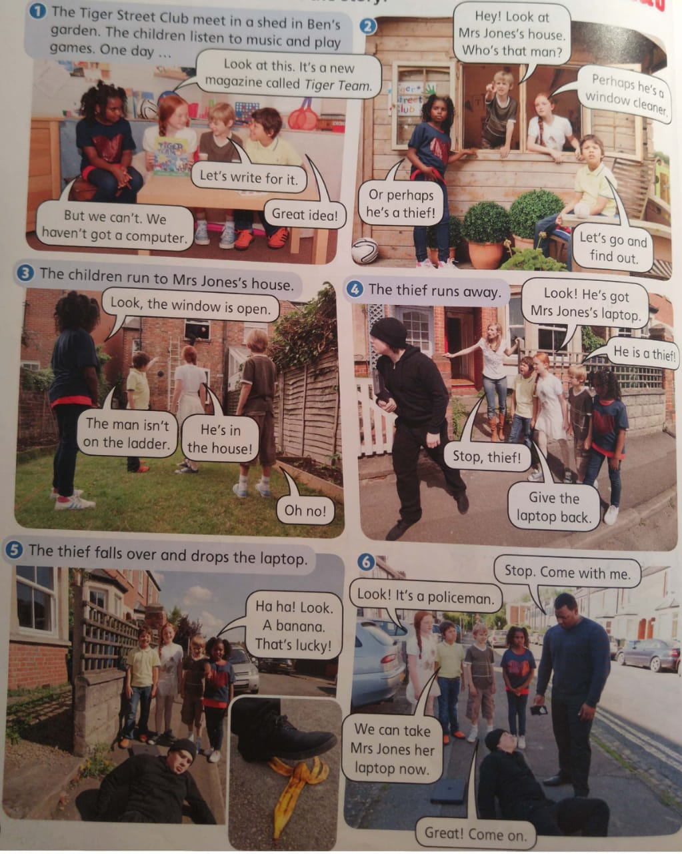

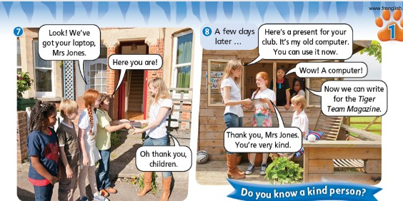

1. **Read and Order**

* The thief takes Mrs Jones’ laptop

**1**

* The children want to write for the Tiger Time Magazine
* Mrs Jones gives the club a present
* They see a thief at Mrs Jones’ house
* The children take Mrs Jones her laptop
* The thief falls over and drops the laptop