Thursday, 24th September

**We use** **DOES in questions.**

Does he wear a uniform**?**

**We use DOES – DOESN’T to answer questions.**

Yes, he does.

Does Positive

Doesn’t Negative

No, he doesn’t.



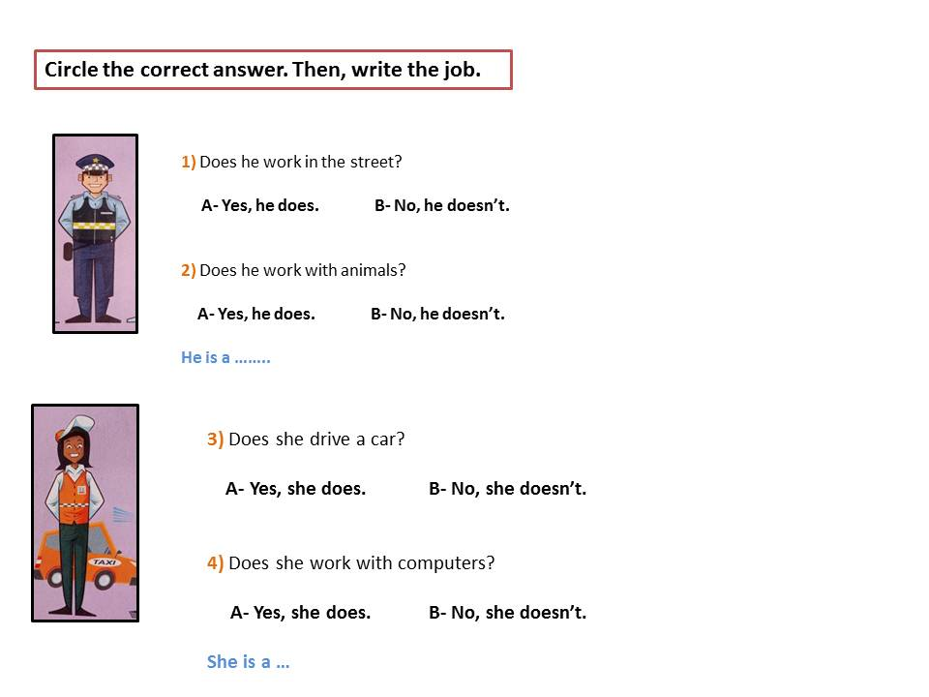

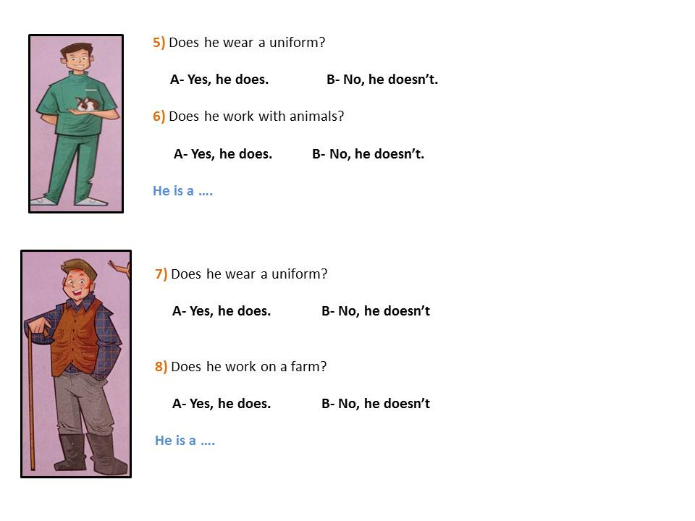



He is a …



She is a …



He is a …



He is a …