Colegio modelo Marmol

6º GRADE

Today is Tuesday, 23RD June 2020

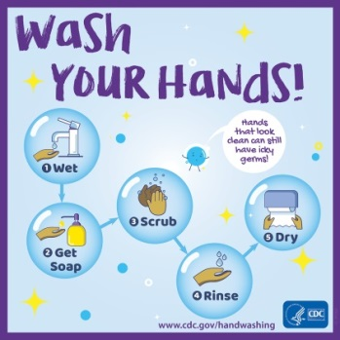  **& **

**Unit 2 – Geographical Wonders**

**READING TIME! ( SB 16 & 17)**



READ AND FOLLOW ALONG THE STORY. AFTER THAT PRACTISE YOUR READING





**Activity book page 16**

<https://es.liveworksheets.com/cq799694dr>

(Resolvemos la actividad online , hacemos click en TERMINADO, completamos con nuestros datos y la envían para la corrección a mi mail [slvncpr@gmail.com](mailto:slvncpr@gmail.com) .)

Sir Edmund Hillary



 

* THREE HUNDRED AND FIFTY
* EIGHT THOUSAND EIGHT HUNDRED AND FIFTY METRES
* FIFTEEN MINUTES
* THIRTY-THREE
* ELEVEN YEARS OLD
* ELEVEN

**MATCH**







