Monday 27th, April

GOOD MORNING EVERYONE!!

1. Let’s listen and read the text. (Listen to the pronunciation and practice reading)

*(Doble click al audio)*



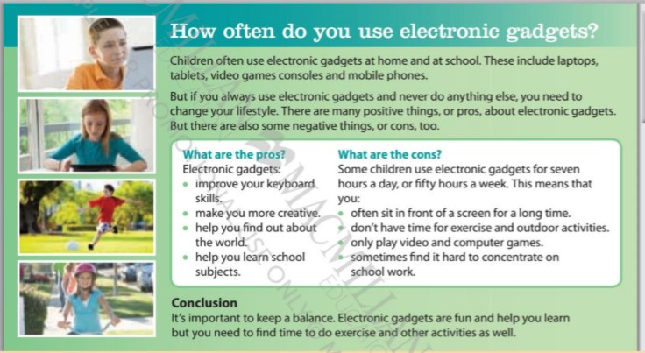

* *Use the dictionary to look for unknown words. (*<https://www.wordreference.com/>)

1. *Choose the correct option*. (Podes usar otro color o resaltarla)

* *What do electronic gadgets improve?*

1. *They improve your keyboard skills*
2. *They improve your concentration*

* *What do they help you find out about?*

1. *They help you find out about only some topics*
2. *They help you find out about the world.*

* *What do they help you learn?*

1. *They help you learn school subjects*
2. *They help you learn nothing*

* *What don’t you have time for?*

1. *You don’t have time for homework*
2. *You don’t have time for exercise and outdoor activities*
3. *Read and write the missing words*

**CREATIVE ~~– LIFESTYLE~~ – CONCENTRATE –**

**CONS – SKILLS**

1. If you always use electronic gadgets and never do anything else, you need to change your LIFESTYLE.
2. There are many pros and ___________ about electronic gadgets.
3. Electronic gadgets improve your keyboard ______________.
4. Electronic gadgets make you more ______________
5. You sometimes find it hard to _______________ on school work.
6. Write P (pro) or C (con)
7. They improve your keyboard skills. P
8. You don´t have time for outdoor activities.
9. They make you more creative.
10. They help you learn school subjects.