Thursday, 27th August

**Booklet** (Page 79)

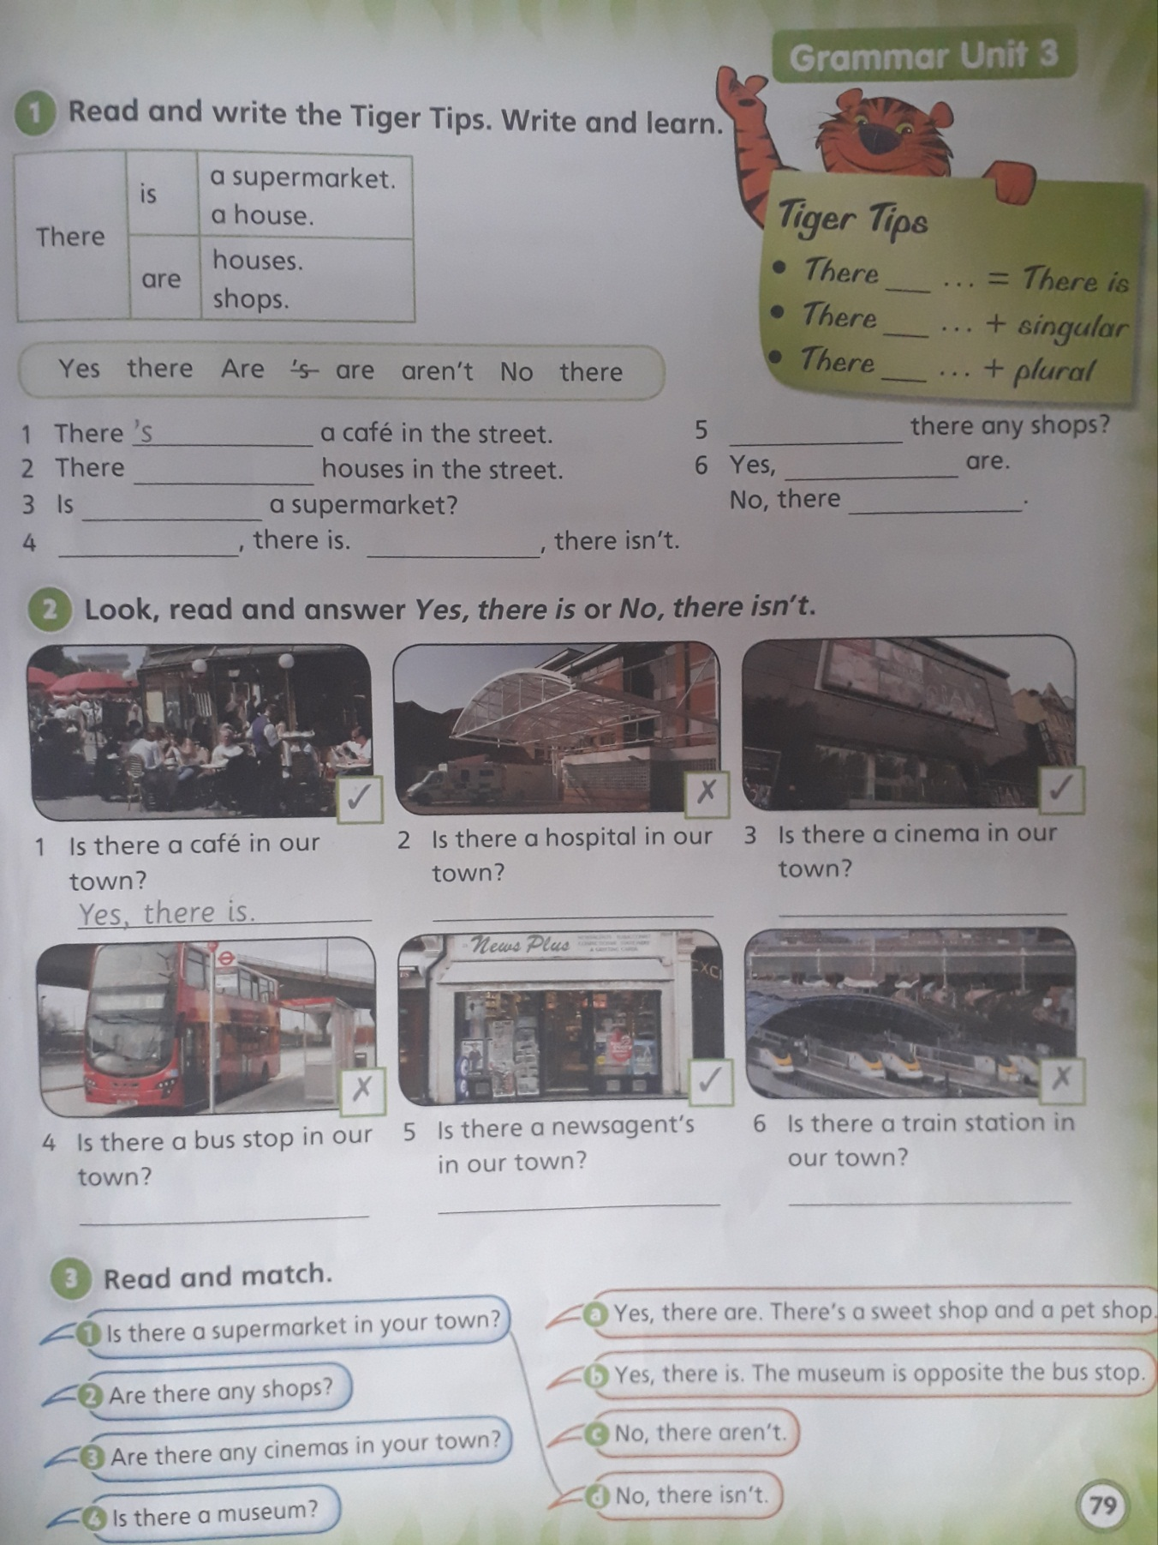

**Activity 1:**

1. **‘S**

**Activity 2:**

1. **Yes, there is.**
2. **No, there isn’t.**

**Activity 3:**

1. **D**