Today is Tuesday 28, April

What’s the weather like? It’s_________________

**PREPOSITIONS.**

**PAY ATTENTION!!!**

**IN UNDER**

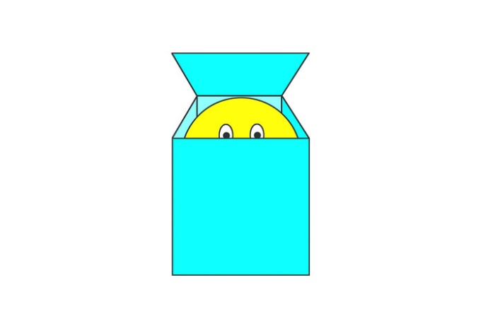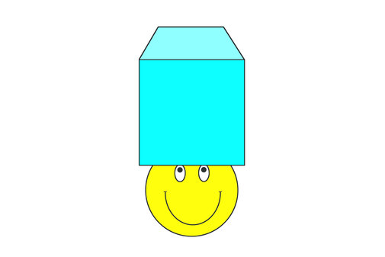

**ON NEXT TO**

  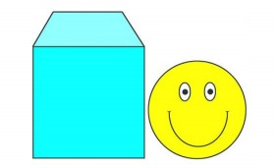

**BEHIND BETWEEN**

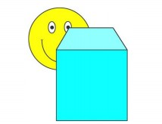 

* **Listen to the song about PREPOSITIONS**

[**https://www.youtube.com/watch?v=fm9-4zCiQng**](https://www.youtube.com/watch?v=fm9-4zCiQng)

Now, complete with a PREPOSITION. *(Mirá nuevamente las fotos que tenés arriba para ayudarte)*

**He is Ed, the elephant**

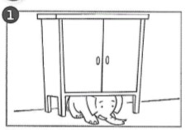**ED IS ___________THE CUPBOARD**

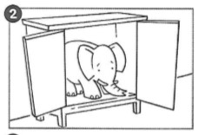**ED IS _____________THE CUPBOARD**

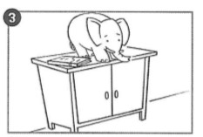**ED IS ____________ THE CUPBOARD**

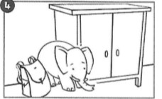**ED IS ______________ THE CUPBOARD**

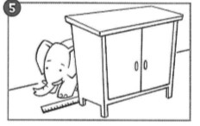**ED IS ______________ THE CUPBOARD**