Thursday, 28th May

**Booklet** (Page 11)

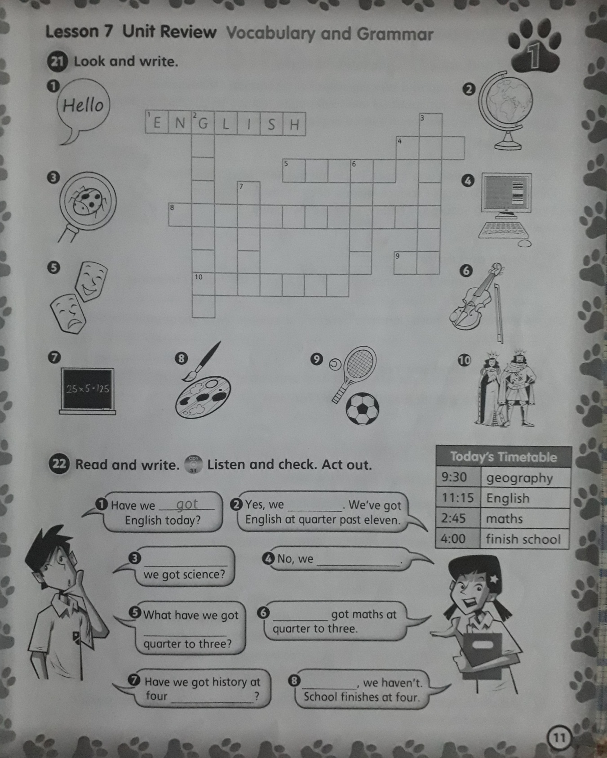

**Activity 21:**

1. English

2-

3-

4-

5-

6-

7-

8-

9-

10-

**Activity 22: (Audio 31)**

1. got

2-

3-

4-

5-

6-

7-

8-