Colegio Modelo Marmol

6ª grade

Today is Monday, 27th April



Where are they from?

**Solve the interactive activity and then copy it in your folder**. ( Resuelve la ficha interactiva y luego copiala en la carpeta)

<https://es.liveworksheets.com/ar137os>

Note: There are two mistakes in the interactive correction because:

Anne **isn’t** from Sweden – It is the Swedish flag 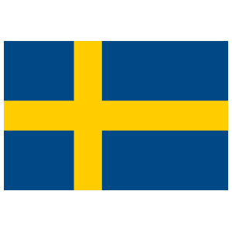

And Kate **is** from Belgium. It is the Belgian flag 

