Colegio Modelo Marmol

6ª grade

Today is Tuesday, 28th April

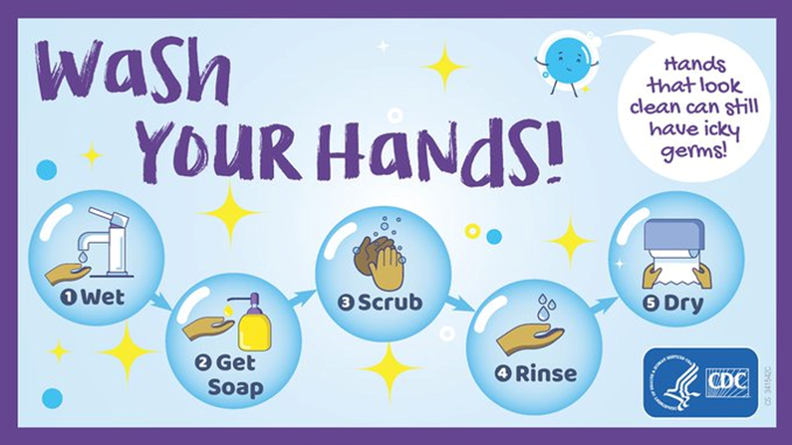

Free time activities

Watch the video “THE TWINS WEEK” and complete the table

<https://www.youtube.com/watch?v=aU0OqbP4JD8>

|  |  |  |
| --- | --- | --- |
| **Days** | **Activities** | **Animals** |
| Monday | Take a shower and watch tv | Hippos and ____________ |
| Tuesday | * ______________________ * Eat dinner | * Pandas and frogs * ______________ |
| Wednesday | * Clean their teeth * ________________ | * ______________ * Rhino |
| Thursday | * Play football * ________________ | * _____________ * _____________ |
| Friday | * _______________ * Play games | * _____________ * _____________ |
| Saturday | * _______________ | * kangaroos |
| Sunday | * walk around the zoo |  |

Write five true sentences

1. They take a shower with the hippos

Complete the pictures

