Tuesday, 30th June

**Atención:** estas actividades **NO** están en el booklet.

1. **Read, choose A or B. Answer the last question.**

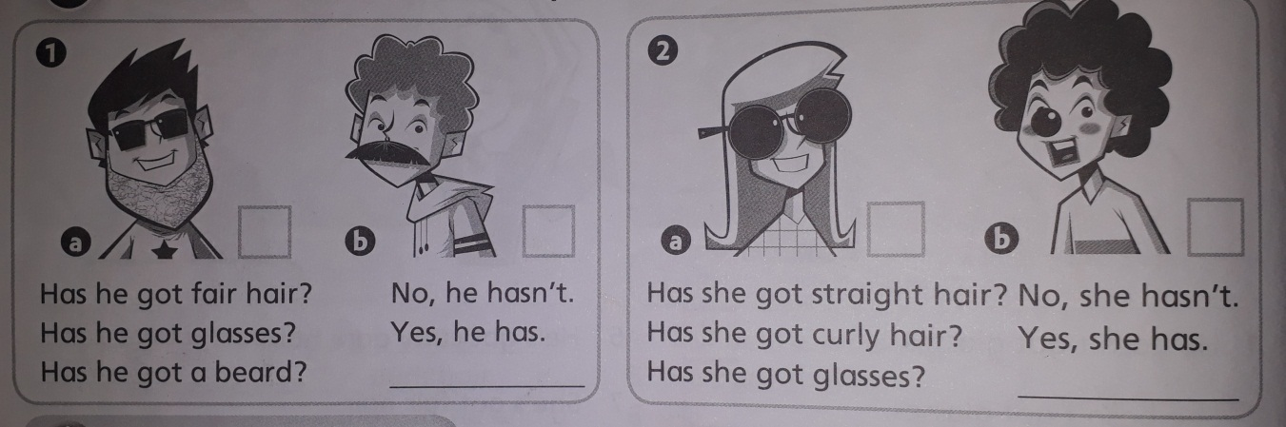

1. Has he got a beard? ……………………

A or B? ……………..

1. Has she got glasses? ………………..

A or B? …………….

1. **Order and write.**

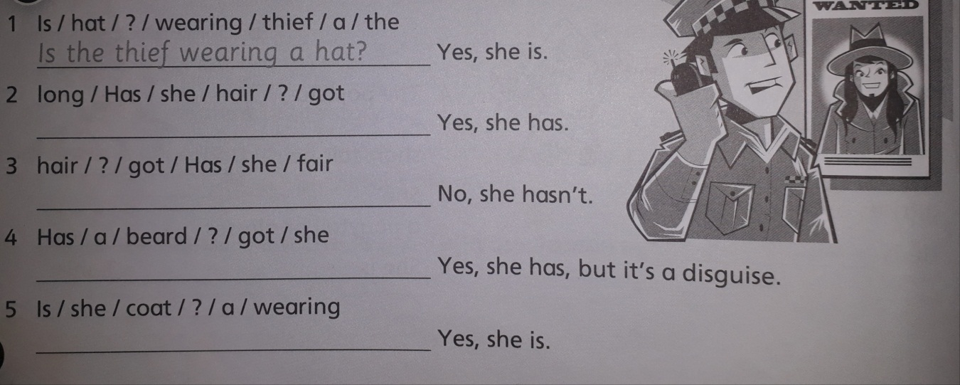

1. **Is the thief wearing a hat?**

2-

3-

4-

5-